UNITED STATES

SECURITIES AND EXCHANGE COMMISSION
WASHINGTON, D.C. 20549

FORM 8-K

CURRENT REPORT

PURSUANT TO SECTION 13 OR 15(D)
OF THE SECURITIES EXCHANGE ACT OF 1934

Date of Report (Date of earliest event reported): November 10, 2021

TEMPEST THERAPEUTICS, INC.

(Exact name of Registrant as Specified in its Charter)

Delaware | 001-35890 | 45-1472564
(State or other jurisdiction | (Commission | (IRS Employer
of incorporation) | File Number) | Identification No.)
 | 7000 Shoreline Court, Suite 275
 | South San Francisco, CA 94080
 | (Address of principal executive offices) (Zip Code)
 | Registrant’s telephone number, including area code: (415) 798-8589
 | N/A
 | (Former Name or Former Address, if Changed Since Last Report)

Check the appropriate box below if the Form 8-K filing is intended to simultaneously satisfy the filing obligation of the registrant under any of the following provisions (see General Instruction A.2. below):

- Written communications pursuant to Rule 425 under the Securities Act (17 CFR 230.425)

- Soliciting material pursuant to Rule 14a-12 under the Exchange Act (17 CFR 240.14a-12)

- Pre-commencement communications pursuant to Rule 14d-2(b) under the Exchange Act (17 CFR 240.14d-2(b))

- Pre-commencement communications pursuant to Rule 13e-4(c) under the Exchange Act (17 CFR 240.13e-4(c))

Securities registered pursuant to Section 12(b) of the Act:

 | Trading | Name of each exchange
Title of each class | Symbol(s) | on which registered
Common Stock, par value $0.001 per share | TPST | The Nasdaq Capital Market

Indicate by check mark whether the registrant is an emerging growth company as defined in Rule 405 of the Securities Act of 1933 (§230.405 of this chapter) or Rule 12b-2 of the Securities Exchange Act of 1934 (§240.12b-2 of this chapter).

Emerging growth company ☐

If an emerging growth company, indicate by check mark if the registrant has elected not to use the extended transition period for complying with any new or revised financial accounting standards provided pursuant to Section 13(a) of the Exchange Act. ☐

Item 2.02 Results of Operations and Financial Condition.

On November 10, 2021, Tempest Therapeutics, Inc. (the “Company”) issued a press release announcing its financial results for the third fiscal quarter ended September 30, 2021. A copy of the Company’s press release dated November 10, 2021, titled “Tempest Reports Third Quarter 2021 Financial Results and Provides Corporate Highlights” is attached hereto as Exhibit 99.1 and is incorporated herein by reference.

The foregoing information (including the exhibit hereto) is being furnished under “Item 2.02 Results of Operations and Financial Condition” and shall not be deemed “filed” for purposes of Section 18 of the Securities Exchange Act of 1934, as amended, nor shall it be deemed incorporated by reference in any filing under the Securities Act of 1933, as amended, except as shall be expressly set forth by specific reference in such filing.

Item 9.01 Financial Statements and Exhibits.

(d) Exhibits.

Exhibit No. | Description
99.1 |  | Press release dated November 10, 2021
104 |  | Cover Page Interactive Data File (embedded within the Inline XBRL document)

SIGNATURES

Pursuant to the requirements of the Securities Exchange Act of 1934, as amended, the Registrant has duly caused this report to be signed on its behalf by the undersigned hereunto duly authorized.

TEMPEST THERAPEUTICS, INC.

Date: November 10, 2021

By:

/s/ Stephen Brady

Name:

Title:

Stephen Brady

Chief Executive Officer

Exhibit 99.1


Tempest Reports Third Quarter 2021 Financial Results and

Provides Corporate Highlights

- First patients dosed in first line, randomized, global Phase 1b/2 hepatocellular carcinoma ("HCC") study of TPST-1120 combination regimen, in collaboration with F. Hoffmann La Roche

- Exclusive rights to novel oncology target in-licensed from the lab of Russell Vance, Ph.D., at the University of California at Berkeley ("U.C. Berkeley")

South San Francisco, CA, November 10, 2021 – Tempest Therapeutics, Inc. (Nasdaq: TPST), a clinical-stage oncology company developing potentially first-in-class therapeutics that combine both targeted and immune-mediated mechanisms, today reported financial results and provided a corporate update for the third quarter ended September 30, 2021.

“The third quarter of 2021 saw continued execution and progress in our programs, including the opening of a collaborative clinical trial with Roche in first line HCC patients comparing TPST-1120 in combination with atezolizumab and bevacizumab to the standard of care regimen, atezolizumab and bevacizumab,” said Stephen R. Brady, chief executive officer of Tempest. “In the fourth quarter of this year and the first half of 2022, we plan to continue this focused approach as our second clinical program, TPST-1495, is poised to move into a set of studies that select patients predicated on strong mechanistic rationale, genetically-defined histologies, and a potential mutation-based biomarker.”

Recent Highlights

- TPST-1495 (clinical dual EP2/4 prostaglandin receptor antagonist): continued enrollment in monotherapy dose optimization towards recommended Phase 2 dose (“RP2D”).

- TPST-1120 (clinical PPARα antagonist): (i) after completion of monotherapy dose escalation, continued enrollment in combination dose escalation towards RP2D; and (ii) commencement of first line, randomized global Phase 1b/2 study in HCC patients, under a collaboration with F. Hoffmann La Roche.

- New Drug Discovery Program: entered into an exclusive license with U.C. Berkeley for intellectual property covering a new drug target discovered in the laboratory of Russell Vance, Ph.D., professor of molecular and cell biology at U.C. Berkeley and a Howard Hughes Medical Institute investigator.

- Advisory Board: announced the appointment of Dr. Vance to Tempest’s Advisory Board, joining a distinguished roster consisting of Toni Choueiri, M.D., Benjamin Cravatt, Ph.D., Raymond DuBois, M.D., Ph.D., Jason Luke, M.D., Drew Pardoll, M.D., and Peppi Prasit, Ph.D.

Planned Near-Term Milestones

- TPST-1495 (clinical dual EP2/4 prostaglandin receptor antagonist): (i) selection of monotherapy RP2D expected in the first half of 2022; (ii) commencement of a combination study with anti-PD-1 checkpoint

Exhibit 99.1

inhibitor expected prior to the end of 2021; and (iii) commencement of monotherapy expansion in targeted indications and biomarker-selected patient populations expected in the first half of 2022.

- TPST-1120 (clinical PPARα antagonist): (i) identification of RP2D of TPST-1120 in combination with nivolumab expected prior to the end of 2021; and (ii) presentation of Phase 1 monotherapy and combination data in mid 2022.

- TREX-1 Inhibitor (preclinical tumor-selective STING pathway activator): planned selection of development candidate in the first half of 2022.

Financial Results

Third Quarter

- Tempest ended the third quarter of 2021 with $59.8 million in cash and cash equivalents and short-term restricted cash, compared to $18.8 million in December 31, 2020. The increase was primarily due to the merger and concurrent PIPE, which closed in June 2021.

- Net loss and net loss per share for the third quarter of 2021 were $8.1 million and $1.21, respectively, compared to $5.4 million and $11.22, respectively, for the third quarter of 2020. The increase was primarily due to an increase in compensation expense and professional fees associated with the merger.

- Research and development expenses for the third quarter of 2021 were $4.6 million, compared to $4.3 million for the same period in 2020. The $0.3 million increase was primarily attributable to increased outside services, insurance and compensation expenses.

- For the three months ended September 30, 2021, general and administrative expenses were $3.1 million compared to $1.2 million for the same period in 2020. The increase was primarily due to growth in compensation and rent expense, as well as, professional fees associated with the merger.

Year-to-Date

- Net cash used in operations for the nine months ended September 30, 2021 was $18.0 million.

- Net loss and net loss per share for the nine months ended September 30, 2021 were $20.5 million and $7.49, respectively, compared to $14.9 million and $31.91, respectively, for the same period in 2020.

- Research and development expenses for the nine months ended September 30, 2021 were $12.5 million compared to $11.4 million for the same period in 2020. The $1.1 million increase was primarily due to increased compensation expenses and consulting services.

- For the nine months ended September 30, 2021, general and administrative expenses were $7.2 million compared to $3.6 million for the same period in 2020.

- Based on current cash position and operating plan, Tempest expects to have sufficient resources to fund operations into the second quarter of 2023.

About Tempest Therapeutics

Tempest Therapeutics is a clinical-stage oncology company advancing small molecules that combine both targeted and immune-mediated mechanisms with the potential to treat a wide range of tumors. The company’s two novel clinical programs are TPST-1495 and TPST-1120, antagonists of EP2/EP4 and PPARα, respectively. Both TPST-1495 and TPST-1120 are advancing through Phase 1 studies designed to study both agents as monotherapies and in combination with other approved agents. In collaboration with F. Hoffman La Roche, TPST-1120 is also advancing through a first line, global, randomized Phase 1b/2 clinical study evaluating TPST-1120 in combination with the standard-of-care regimen of atezolizumab and bevacizumab in patients with advanced or metastatic hepatocellular carcinoma. Tempest is also developing an orally-available inhibitor of TREX-1 designed to activate selectively the cGAS/STING pathway, an innate immune response pathway important for the development of anti-tumor immunity. Tempest is headquartered in South San Francisco. More information about Tempest can be found on the company’s website at www.tempesttx.com.

Exhibit 99.1

Forward-Looking Statements

This press release contains forward-looking statements (including within the meaning of Section 21E of the Securities Exchange Act of 1934, as amended, and Section 27A of the Securities Act of 1933, as amended (the “Securities Act”)) concerning Tempest Therapeutics, Inc. (“Tempest Therapeutics”). These statements may discuss goals, intentions, and expectations as to future plans, trends, events, results of operations or financial condition, or otherwise, based on current beliefs of the management of Tempest Therapeutics, as well as assumptions made by, and information currently available to, management of Tempest Therapeutics. Forward-looking statements generally include statements that are predictive in nature and depend upon or refer to future events or conditions, and include words such as “may,” “will,” “should,” “would,” “could”, “expect,” “anticipate,” “plan,” “likely,” “believe,” “estimate,” “project,” “intend,” and other similar expressions. All statements that are not historical facts are forward-looking statements, including any statements regarding the timing and selection of development candidates, dose selection or commencement of, or availability of data from, clinical trials, the company’s guidance regarding cash resources as well as our operational plans and the timing and ability to deliver on value-creating milestones. Forward-looking statements are based on information available to Tempest Therapeutics as of the date hereof and are not guarantees of future performance. Actual results could differ materially from those contained in any forward-looking statement. These and other risks are described in greater detail in the Form 10-Q filed by Tempest Therapeutics with the Securities and Exchange Commission on November 11, 2021. Except as required by applicable law, Tempest Therapeutics undertakes no obligation to revise or update any forward-looking statement, or to make any other forward-looking statements, whether as a result of new information, future events or otherwise. These forward-looking statements should not be relied upon as representing Tempest Therapeutics’ views as of any date subsequent to the date of this press release and should not be relied upon as prediction of future events. In light of the foregoing, investors are urged not to rely on any forward-looking statement in reaching any conclusion or making any investment decision about any securities of Tempest Therapeutics.

Exhibit 99.1
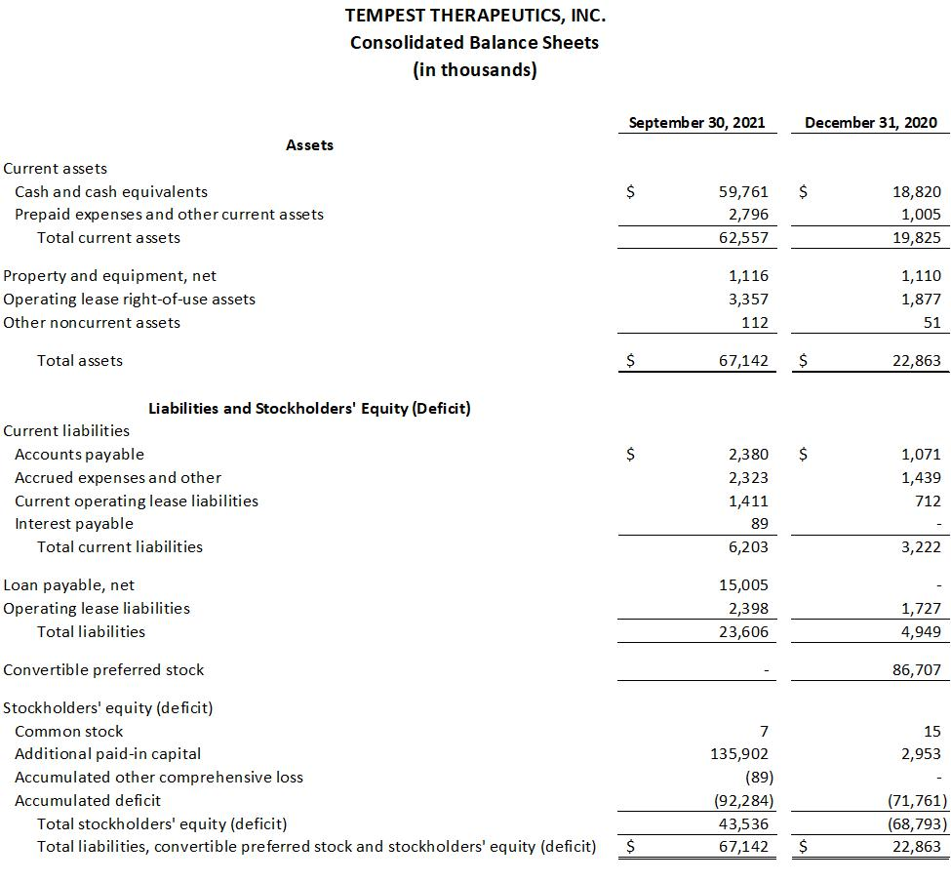

Exhibit 99.1
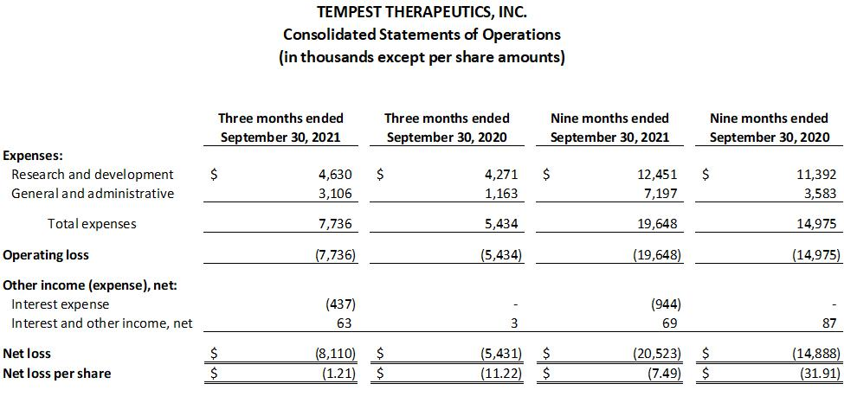

Investor Contacts:

Sylvia Wheeler

Wheelhouse Life Science Advisors

swheeler@wheelhouselsa.com

Aljanae Reynolds

Wheelhouse Life Science Advisors

areynolds@wheelhouselsa.com

