UNITED STATES
SECURITIES AND EXCHANGE COMMISSION
WASHINGTON, D.C. 20549

FORM 8-K

CURRENT REPORT
Pursuant to Section 13 or 15(d)
of the Securities Exchange Act of 1934
Date of Report (Date of earliest event reported): February 11, 2026

Tempest Therapeutics, Inc.
(Exact name of Registrant as Specified in Its Charter)

Delaware |  | 001-35890 |  | 45-1472564
(State or Other Jurisdiction  of Incorporation) |  | (Commission  File Number) |  | (IRS Employer  Identification No.)
2000 Sierra Point Parkway, Suite 400
Brisbane, California |  |  |  | 94005
(Address of Principal Executive Offices) |  |  |  | (Zip Code)
Registrant’s Telephone Number, Including Area Code: (415) 798-8589

(Former Name or Former Address, if Changed Since Last Report)

Check the appropriate box below if the Form 8-K filing is intended to simultaneously satisfy the filing obligation of the registrant under any of the following provisions:

☐ | Written communications pursuant to Rule 425 under the Securities Act (17 CFR 230.425)

☐ | Soliciting material pursuant to Rule 14a-12 under the Exchange Act (17 CFR 240.14a-12)

☐ | Pre-commencement communications pursuant to Rule 14d-2(b) under the Exchange Act (17 CFR 240.14d-2(b))

☐ | Pre-commencement communications pursuant to Rule 13e-4(c) under the Exchange Act (17 CFR 240.13e-4(c))
Securities registered pursuant to Section 12(b) of the Act:

Title of each class |  | Trading  Symbol(s) |  | Name of each exchange  on which registered
Common Stock, $0.001 par value |  | TPST |  | The Nasdaq Stock Market LLC
Series A Junior Participating Preferred Purchase Rights |  | N/A |  | The Nasdaq Stock Market LLC
Indicate by check mark whether the registrant is an emerging growth company as defined in Rule 405 of the Securities Act of 1933 (§ 230.405 of this chapter) or Rule 12b-2 of the Securities Exchange Act of 1934 (§ 240.12b-2 of this chapter).
Emerging growth company ☐
If an emerging growth company, indicate by check mark if the registrant has elected not to use the extended transition period for complying with any new or revised financial accounting standards provided pursuant to Section 13(a) of the Exchange Act. ☐

Item 7.01 | Regulation FD Disclosure
On February 11, 2026, Tempest Therapeutics, Inc. (the “Company”) intends to post an updated corporate presentation, dated February 2026, to the “News, Events & Presentations” subsection of the “Investors” tab on the Company’s website at www.tempesttx.com. A copy of the corporate presentation is attached hereto as Exhibit 99.1 and is incorporated by reference into this Item 7.01.
The foregoing information (including Exhibit 99.1 hereto) is being furnished and shall not be deemed “filed” for purposes of Section 18 of the Securities Exchange Act of 1934, as amended, or otherwise subject to the liabilities of that section, nor shall it be deemed incorporated by reference in any filing under the Securities Act of 1933, as amended, except as shall be expressly set forth by specific reference in such filing.

Item 9.01 | Financial Statements and Exhibits.
(d) Exhibits.

Exhibit  No. |  | Description
99.1 |  | Investor Presentation dated February 2026
104 |  | Cover Page Interactive Data File (embedded within the Inline XBRL document)

SIGNATURES
Pursuant to the requirements of the Securities Exchange Act of 1934, the registrant has duly caused this report to be signed on its behalf by the undersigned hereunto duly authorized.

 |  |  |  |  |  | TEMPEST THERAPEUTICS, INC.
Date: February 11, 2026 |  |  |  | By: |  | /s/ Matthew Angel
 |  |  |  | Name: |  | Matthew Angel
 |  |  |  | Title: |  | Chief Executive Officer

Exhibit 99.1 ® Accelerating the Development of Advanced Therapies for Cancer Patients February 2026

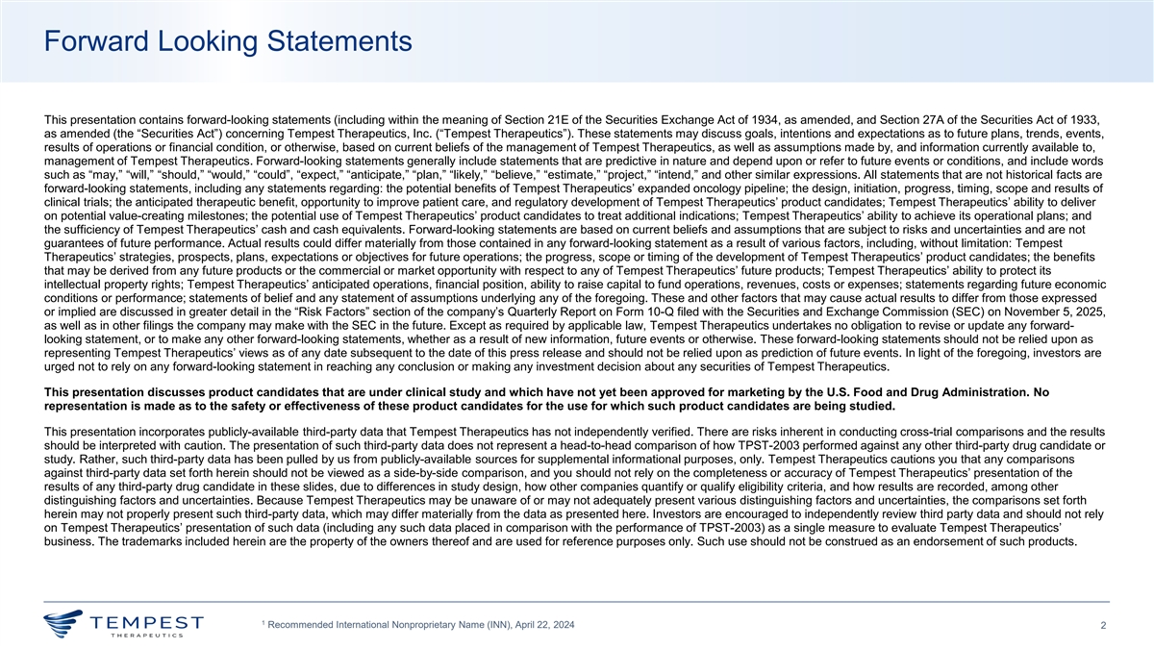
Forward Looking Statements This presentation contains forward-looking statements (including within the meaning of Section 21E of the Securities Exchange Act of 1934, as amended, and Section 27A of the Securities Act of 1933, as amended (the “Securities Act”) concerning Tempest Therapeutics, Inc. (“Tempest Therapeutics”). These statements may discuss goals, intentions and expectations as to future plans, trends, events, results of operations or financial condition, or otherwise, based on current beliefs of the management of Tempest Therapeutics, as well as assumptions made by, and information currently available to, management of Tempest Therapeutics. Forward-looking statements generally include statements that are predictive in nature and depend upon or refer to future events or conditions, and include words such as “may,” “will,” “should,” “would,” “could”, “expect,” “anticipate,” “plan,” “likely,” “believe,” “estimate,” “project,” “intend,” and other similar expressions. All statements that are not historical facts are forward-looking statements, including any statements regarding: the potential benefits of Tempest Therapeutics’ expanded oncology pipeline; the design, initiation, progress, timing, scope and results of clinical trials; the anticipated therapeutic benefit, opportunity to improve patient care, and regulatory development of Tempest Therapeutics’ product candidates; Tempest Therapeutics’ ability to deliver on potential value-creating milestones; the potential use of Tempest Therapeutics’ product candidates to treat additional indications; Tempest Therapeutics’ ability to achieve its operational plans; and the sufficiency of Tempest Therapeutics’ cash and cash equivalents. Forward-looking statements are based on current beliefs and assumptions that are subject to risks and uncertainties and are not guarantees of future performance. Actual results could differ materially from those contained in any forward-looking statement as a result of various factors, including, without limitation: Tempest Therapeutics’ strategies, prospects, plans, expectations or objectives for future operations; the progress, scope or timing of the development of Tempest Therapeutics’ product candidates; the benefits that may be derived from any future products or the commercial or market opportunity with respect to any of Tempest Therapeutics’ future products; Tempest Therapeutics’ ability to protect its intellectual property rights; Tempest Therapeutics’ anticipated operations, financial position, ability to raise capital to fund operations, revenues, costs or expenses; statements regarding future economic conditions or performance; statements of belief and any statement of assumptions underlying any of the foregoing. These and other factors that may cause actual results to differ from those expressed or implied are discussed in greater detail in the “Risk Factors” section of the company’s Quarterly Report on Form 10-Q filed with the Securities and Exchange Commission (SEC) on November 5, 2025, as well as in other filings the company may make with the SEC in the future. Except as required by applicable law, Tempest Therapeutics undertakes no obligation to revise or update any forward- looking statement, or to make any other forward-looking statements, whether as a result of new information, future events or otherwise. These forward-looking statements should not be relied upon as representing Tempest Therapeutics’ views as of any date subsequent to the date of this press release and should not be relied upon as prediction of future events. In light of the foregoing, investors are urged not to rely on any forward-looking statement in reaching any conclusion or making any investment decision about any securities of Tempest Therapeutics. This presentation discusses product candidates that are under clinical study and which have not yet been approved for marketing by the U.S. Food and Drug Administration. No representation is made as to the safety or effectiveness of these product candidates for the use for which such product candidates are being studied. This presentation incorporates publicly-available third-party data that Tempest Therapeutics has not independently verified. There are risks inherent in conducting cross-trial comparisons and the results should be interpreted with caution. The presentation of such third-party data does not represent a head-to-head comparison of how TPST-2003 performed against any other third-party drug candidate or study. Rather, such third-party data has been pulled by us from publicly-available sources for supplemental informational purposes, only. Tempest Therapeutics cautions you that any comparisons against third-party data set forth herein should not be viewed as a side-by-side comparison, and you should not rely on the completeness or accuracy of Tempest Therapeutics’ presentation of the results of any third-party drug candidate in these slides, due to differences in study design, how other companies quantify or qualify eligibility criteria, and how results are recorded, among other distinguishing factors and uncertainties. Because Tempest Therapeutics may be unaware of or may not adequately present various distinguishing factors and uncertainties, the comparisons set forth herein may not properly present such third-party data, which may differ materially from the data as presented here. Investors are encouraged to independently review third party data and should not rely on Tempest Therapeutics’ presentation of such data (including any such data placed in comparison with the performance of TPST-2003) as a single measure to evaluate Tempest Therapeutics’ business. The trademarks included herein are the property of the owners thereof and are used for reference purposes only. Such use should not be construed as an endorsement of such products. 1 Recommended International Nonproprietary Name (INN), April 22, 2024 2

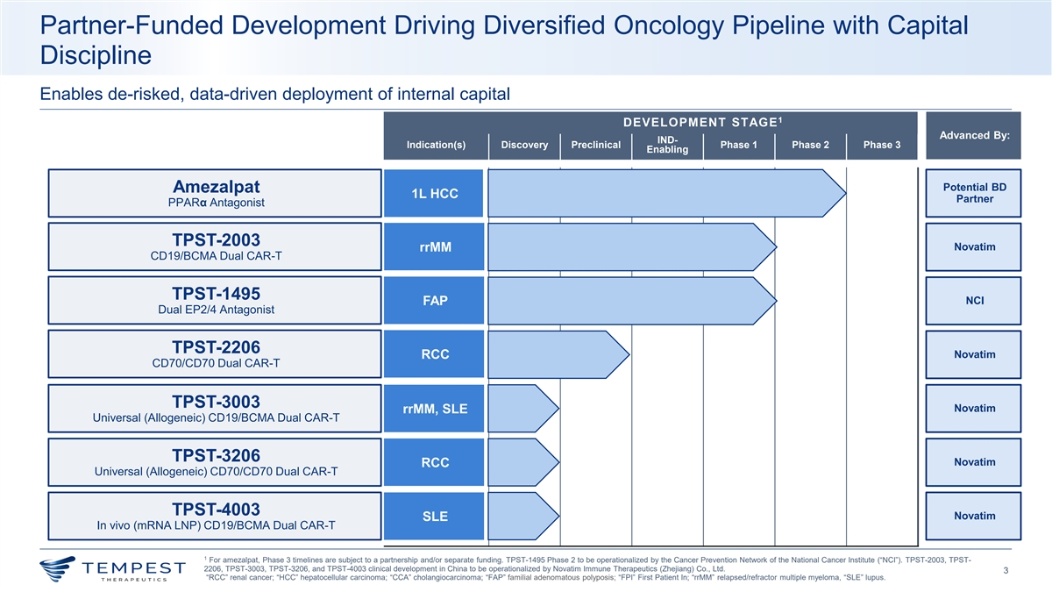
Partner-Funded Development Driving Diversified Oncology Pipeline with Capital Discipline Enables de-risked, data-driven deployment of internal capital 1 DEVELOPMENT STAGE Advanced By: IND- Indication(s) Discovery Preclinical Phase 1 Phase 2 Phase 3 Enabling Potential BD Amezalpat 1L HCC Partner PPARα Antagonist TPST-2003 Novatim rrMM CD19/BCMA Dual CAR-T TPST-1495 NCI FAP Dual EP2/4 Antagonist TPST-2206 RCC Novatim CD70/CD70 Dual CAR-T TPST-3003 Novatim rrMM, SLE Universal (Allogeneic) CD19/BCMA Dual CAR-T TPST-3206 Novatim RCC Universal (Allogeneic) CD70/CD70 Dual CAR-T TPST-4003 Novatim SLE In vivo (mRNA LNP) CD19/BCMA Dual CAR-T 1 For amezalpat, Phase 3 timelines are subject to a partnership and/or separate funding. TPST-1495 Phase 2 to be operationalized by the Cancer Prevention Network of the National Cancer Institute (“NCI”). TPST-2003, TPST- 2206, TPST-3003, TPST-3206, and TPST-4003 clinical development in China to be operationalized by Novatim Immune Therapeutics (Zhejiang) Co., Ltd. 3 “RCC” renal cancer; “HCC” hepatocellular carcinoma; “CCA” cholangiocarcinoma; “FAP” familial adenomatous polyposis; “FPI” First Patient In; “rrMM” relapsed/refractor multiple myeloma, “SLE” lupus.

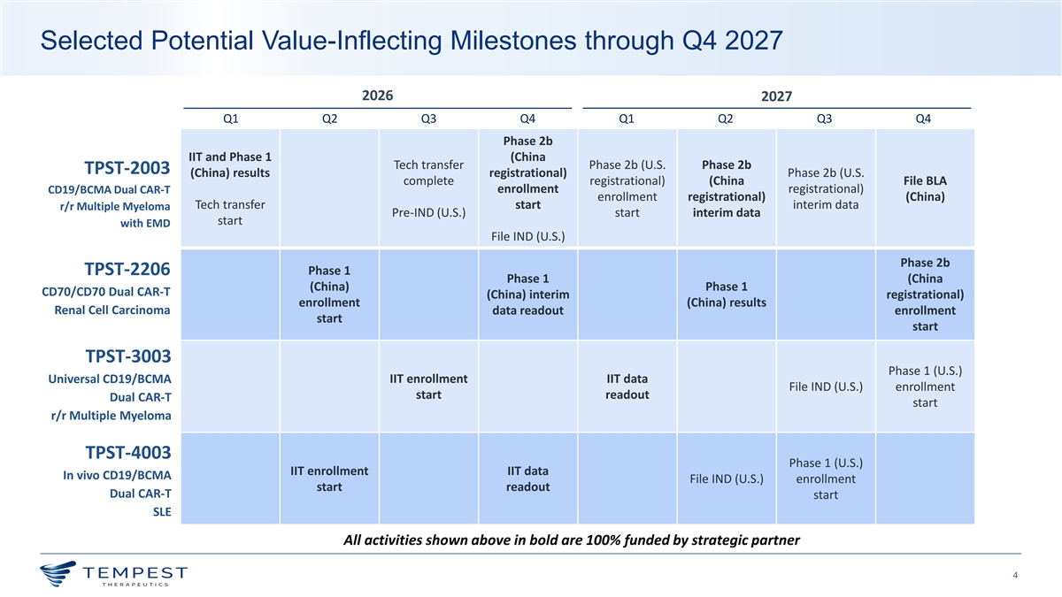
Selected Potential Value-Inflecting Milestones through Q4 2027 2026 2027 Q1 Q2 Q3 Q4 Q1 Q2 Q3 Q4 Phase 2b IIT and Phase 1 (China Tech transfer Phase 2b (U.S. Phase 2b TPST-2003 (China) results registrational) Phase 2b (U.S. complete registrational) (China File BLA CD19/BCMA Dual CAR-T enrollment registrational) enrollment registrational) (China) Tech transfer start interim data r/r Multiple Myeloma Pre-IND (U.S.) start interim data start with EMD File IND (U.S.) Phase 2b TPST-2206 Phase 1 Phase 1 (China (China) Phase 1 CD70/CD70 Dual CAR-T (China) interim registrational) enrollment (China) results Renal Cell Carcinoma data readout enrollment start start TPST-3003 Phase 1 (U.S.) IIT enrollment IIT data Universal CD19/BCMA File IND (U.S.) enrollment start readout Dual CAR-T start r/r Multiple Myeloma TPST-4003 Phase 1 (U.S.) IIT enrollment IIT data In vivo CD19/BCMA File IND (U.S.) enrollment start readout Dual CAR-T start SLE All activities shown above in bold are 100% funded by strategic partner 4

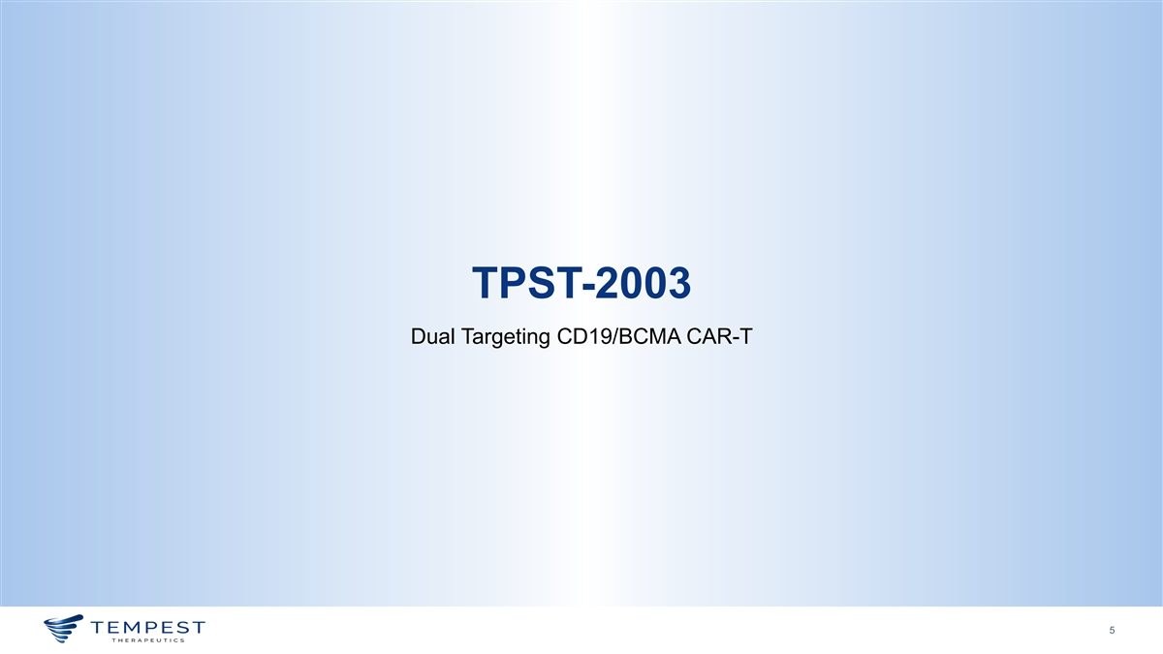
TPST-2003 Dual Targeting CD19/BCMA CAR-T 5

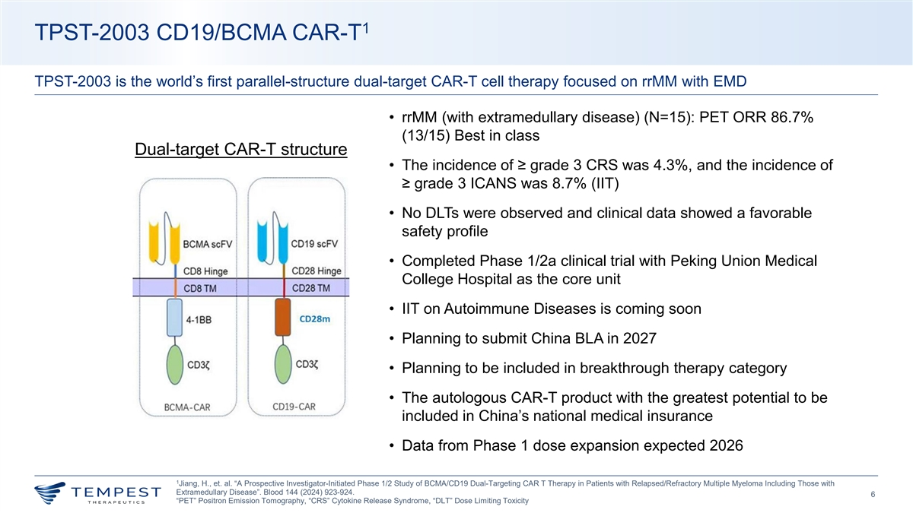
1 TPST-2003 CD19/BCMA CAR-T TPST-2003 is the world’s first parallel-structure dual-target CAR-T cell therapy focused on rrMM with EMD • rrMM (with extramedullary disease) (N=15): PET ORR 86.7% (13/15) Best in class Dual-target CAR-T structure • The incidence of ≥ grade 3 CRS was 4.3%, and the incidence of ≥ grade 3 ICANS was 8.7% (IIT) • No DLTs were observed and clinical data showed a favorable safety profile • Completed Phase 1/2a clinical trial with Peking Union Medical College Hospital as the core unit • IIT on Autoimmune Diseases is coming soon • Planning to submit China BLA in 2027 • Planning to be included in breakthrough therapy category • The autologous CAR-T product with the greatest potential to be included in China’s national medical insurance • Data from Phase 1 dose expansion expected 2026 1 Jiang, H., et. al. “A Prospective Investigator-Initiated Phase 1/2 Study of BCMA/CD19 Dual-Targeting CAR T Therapy in Patients with Relapsed/Refractory Multiple Myeloma Including Those with Extramedullary Disease”. Blood 144 (2024) 923-924. 6 “PET” Positron Emission Tomography, “CRS” Cytokine Release Syndrome, “DLT” Dose Limiting Toxicity

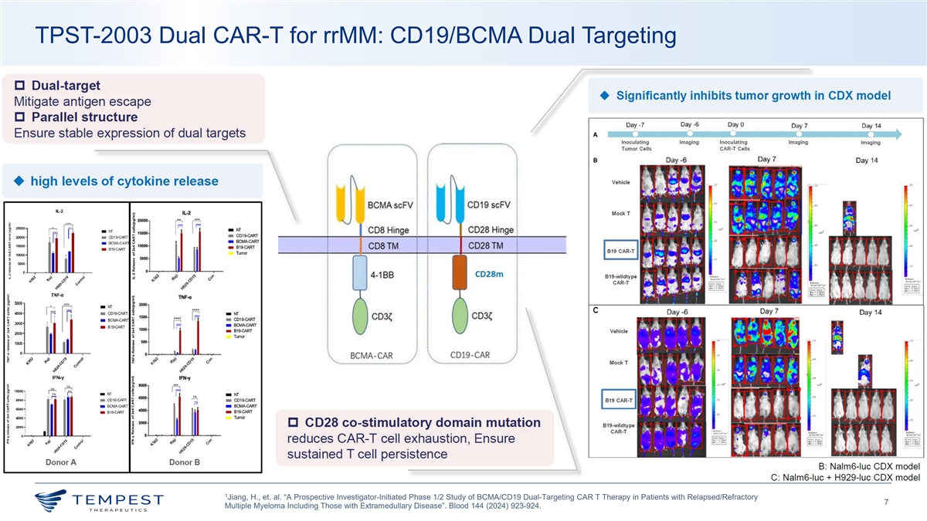
TPST-2003 Dual CAR-T for rrMM: CD19/BCMA Dual Targeting 1 Jiang, H., et. al. “A Prospective Investigator-Initiated Phase 1/2 Study of BCMA/CD19 Dual-Targeting CAR T Therapy in Patients with Relapsed/Refractory 7 Multiple Myeloma Including Those with Extramedullary Disease”. Blood 144 (2024) 923-924.

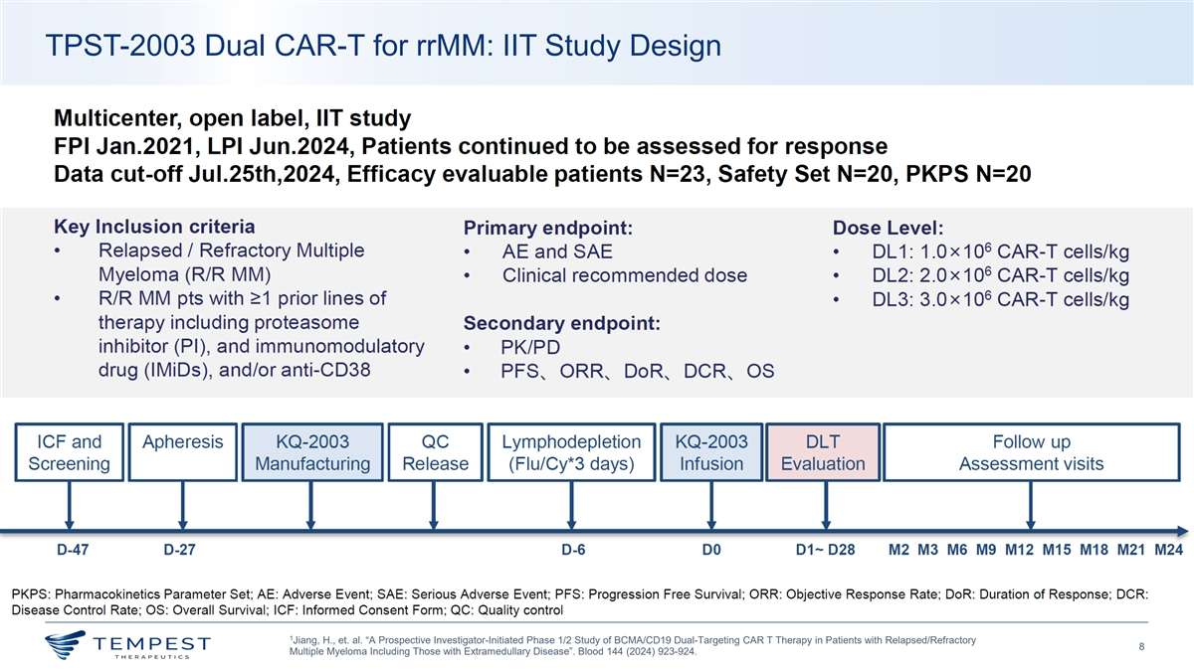
TPST-2003 Dual CAR-T for rrMM: IIT Study Design 1 Jiang, H., et. al. “A Prospective Investigator-Initiated Phase 1/2 Study of BCMA/CD19 Dual-Targeting CAR T Therapy in Patients with Relapsed/Refractory 8 Multiple Myeloma Including Those with Extramedullary Disease”. Blood 144 (2024) 923-924.

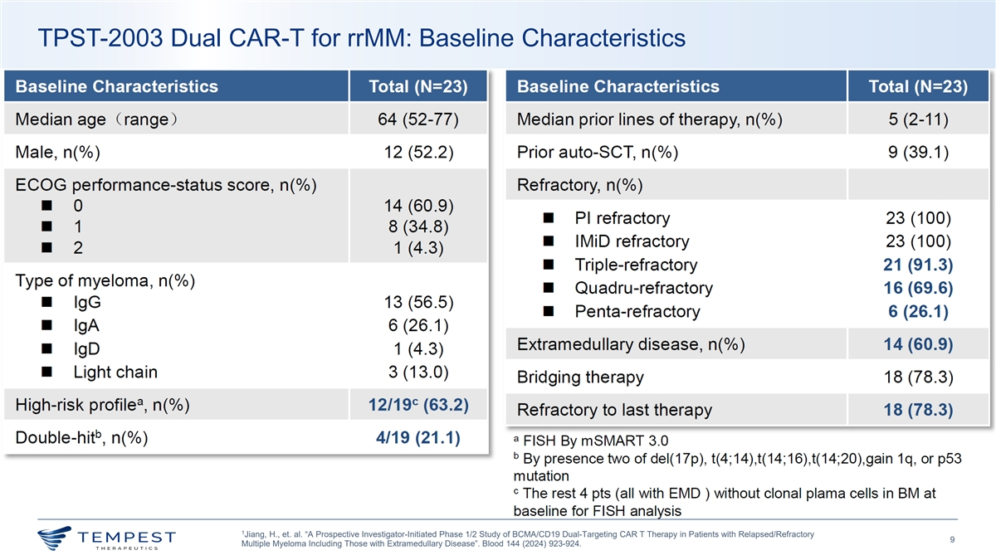
TPST-2003 Dual CAR-T for rrMM: Baseline Characteristics 1 Jiang, H., et. al. “A Prospective Investigator-Initiated Phase 1/2 Study of BCMA/CD19 Dual-Targeting CAR T Therapy in Patients with Relapsed/Refractory 9 Multiple Myeloma Including Those with Extramedullary Disease”. Blood 144 (2024) 923-924.

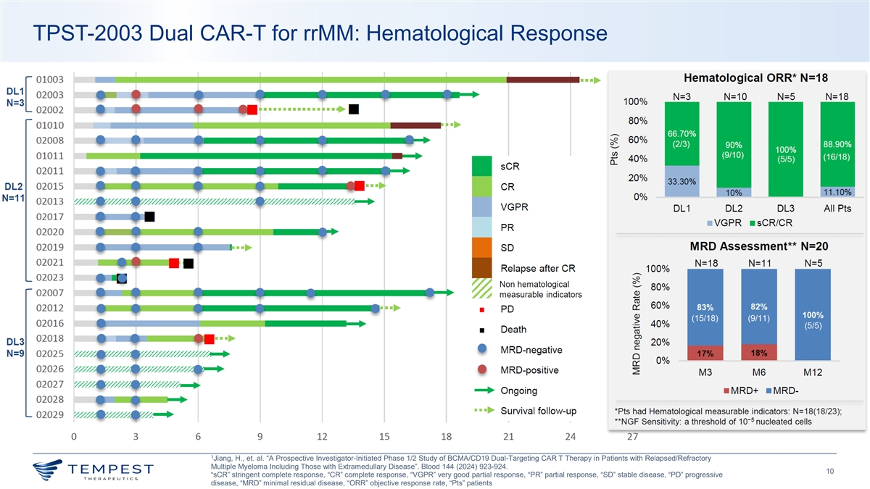
TPST-2003 Dual CAR-T for rrMM: Hematological Response 1 Jiang, H., et. al. “A Prospective Investigator-Initiated Phase 1/2 Study of BCMA/CD19 Dual-Targeting CAR T Therapy in Patients with Relapsed/Refractory Multiple Myeloma Including Those with Extramedullary Disease”. Blood 144 (2024) 923-924. 10 “sCR” stringent complete response, “CR” complete response, “VGPR” very good partial response, “PR” partial response, “SD” stable disease, “PD” progressive disease, “MRD” minimal residual disease, “ORR” objective response rate, “Pts” patients

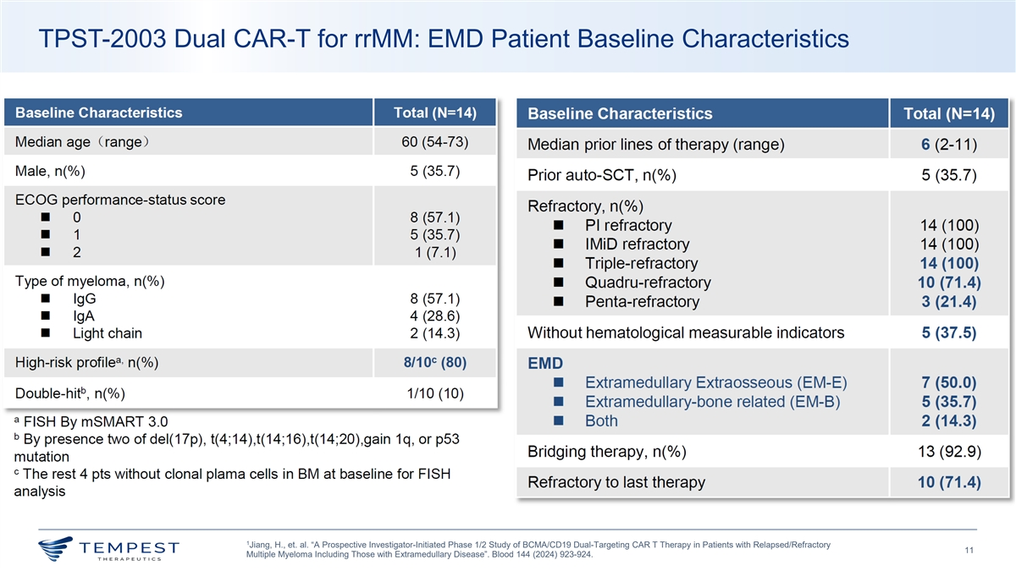
TPST-2003 Dual CAR-T for rrMM: EMD Patient Baseline Characteristics 1 Jiang, H., et. al. “A Prospective Investigator-Initiated Phase 1/2 Study of BCMA/CD19 Dual-Targeting CAR T Therapy in Patients with Relapsed/Refractory 11 Multiple Myeloma Including Those with Extramedullary Disease”. Blood 144 (2024) 923-924.

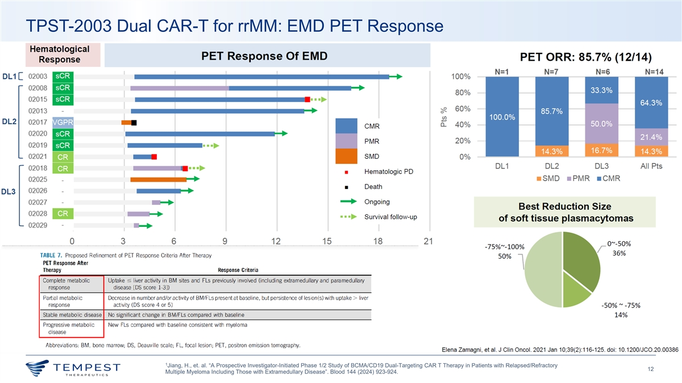
TPST-2003 Dual CAR-T for rrMM: EMD PET Response 1 Jiang, H., et. al. “A Prospective Investigator-Initiated Phase 1/2 Study of BCMA/CD19 Dual-Targeting CAR T Therapy in Patients with Relapsed/Refractory 12 Multiple Myeloma Including Those with Extramedullary Disease”. Blood 144 (2024) 923-924.

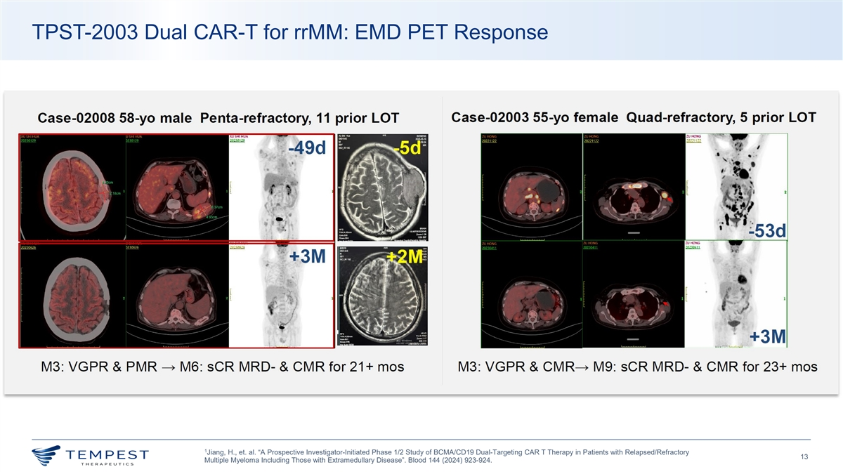
TPST-2003 Dual CAR-T for rrMM: EMD PET Response 1 Jiang, H., et. al. “A Prospective Investigator-Initiated Phase 1/2 Study of BCMA/CD19 Dual-Targeting CAR T Therapy in Patients with Relapsed/Refractory 13 Multiple Myeloma Including Those with Extramedullary Disease”. Blood 144 (2024) 923-924.

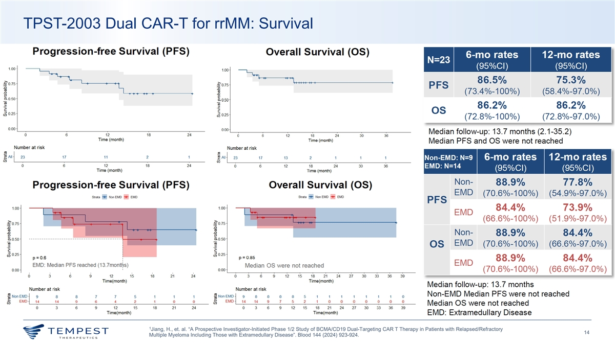
TPST-2003 Dual CAR-T for rrMM: Survival 1 Jiang, H., et. al. “A Prospective Investigator-Initiated Phase 1/2 Study of BCMA/CD19 Dual-Targeting CAR T Therapy in Patients with Relapsed/Refractory 14 Multiple Myeloma Including Those with Extramedullary Disease”. Blood 144 (2024) 923-924.

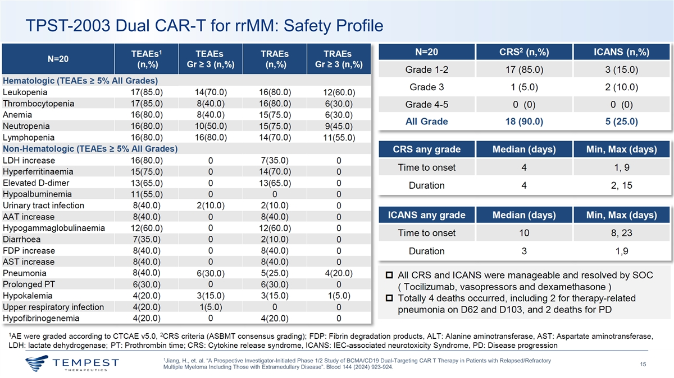
TPST-2003 Dual CAR-T for rrMM: Safety Profile 1 Jiang, H., et. al. “A Prospective Investigator-Initiated Phase 1/2 Study of BCMA/CD19 Dual-Targeting CAR T Therapy in Patients with Relapsed/Refractory 15 Multiple Myeloma Including Those with Extramedullary Disease”. Blood 144 (2024) 923-924.

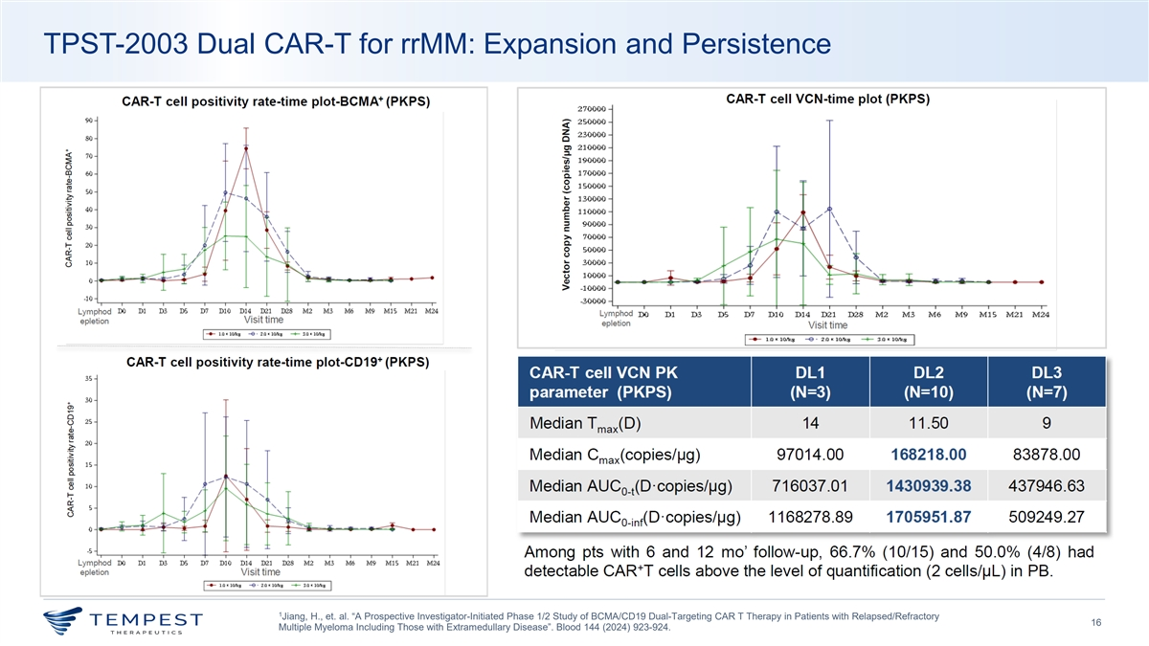
TPST-2003 Dual CAR-T for rrMM: Expansion and Persistence 1 Jiang, H., et. al. “A Prospective Investigator-Initiated Phase 1/2 Study of BCMA/CD19 Dual-Targeting CAR T Therapy in Patients with Relapsed/Refractory 16 Multiple Myeloma Including Those with Extramedullary Disease”. Blood 144 (2024) 923-924.

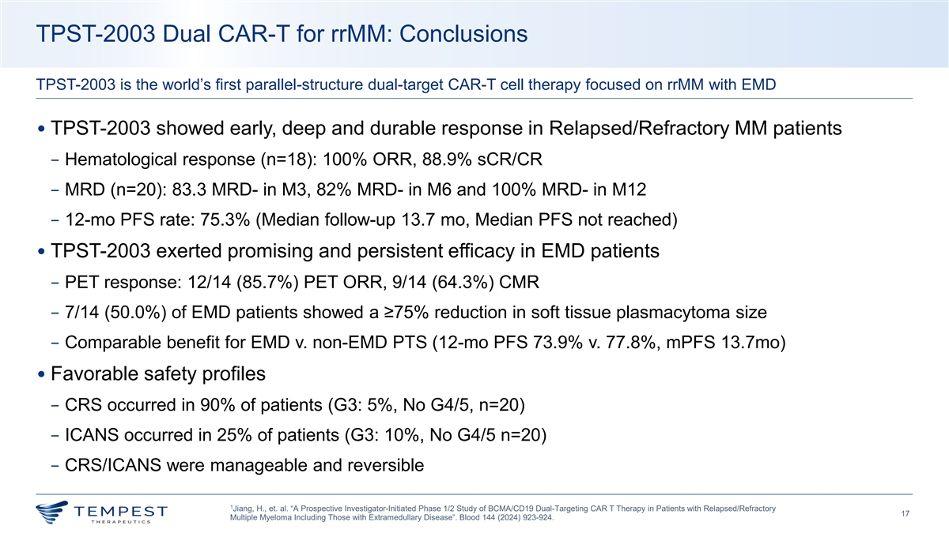
TPST-2003 Dual CAR-T for rrMM: Conclusions TPST-2003 is the world’s first parallel-structure dual-target CAR-T cell therapy focused on rrMM with EMD • TPST-2003 showed early, deep and durable response in Relapsed/Refractory MM patients − Hematological response (n=18): 100% ORR, 88.9% sCR/CR − MRD (n=20): 83.3 MRD- in M3, 82% MRD- in M6 and 100% MRD- in M12 − 12-mo PFS rate: 75.3% (Median follow-up 13.7 mo, Median PFS not reached) • TPST-2003 exerted promising and persistent efficacy in EMD patients − PET response: 12/14 (85.7%) PET ORR, 9/14 (64.3%) CMR − 7/14 (50.0%) of EMD patients showed a ≥75% reduction in soft tissue plasmacytoma size − Comparable benefit for EMD v. non-EMD PTS (12-mo PFS 73.9% v. 77.8%, mPFS 13.7mo) • Favorable safety profiles − CRS occurred in 90% of patients (G3: 5%, No G4/5, n=20) − ICANS occurred in 25% of patients (G3: 10%, No G4/5 n=20) − CRS/ICANS were manageable and reversible 1 Jiang, H., et. al. “A Prospective Investigator-Initiated Phase 1/2 Study of BCMA/CD19 Dual-Targeting CAR T Therapy in Patients with Relapsed/Refractory 17 Multiple Myeloma Including Those with Extramedullary Disease”. Blood 144 (2024) 923-924.

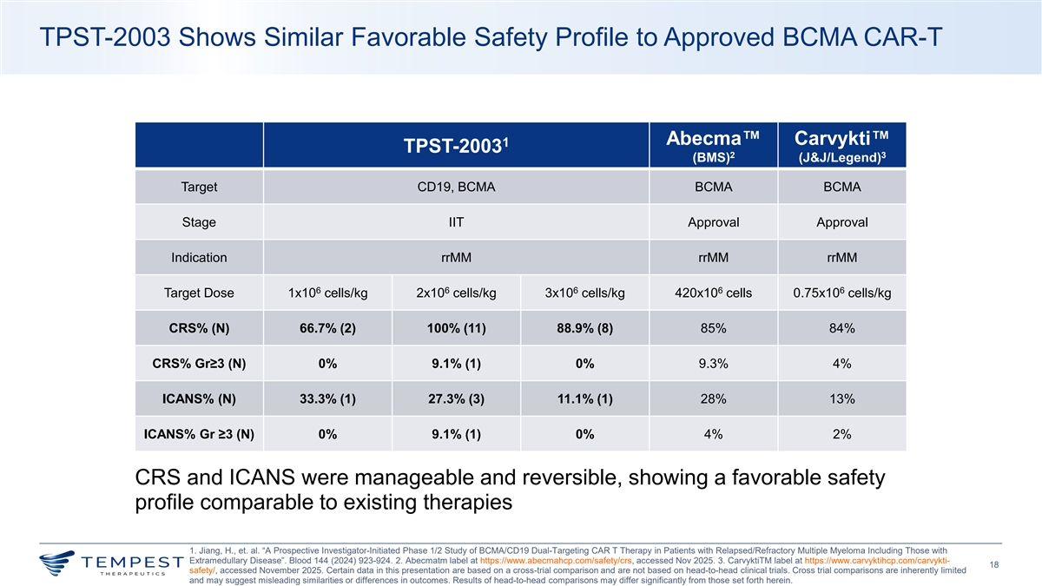
TPST-2003 Shows Similar Favorable Safety Profile to Approved BCMA CAR-T Abecma Carvykti 1 TPST-2003 2 3 (BMS) (J&J/Legend) Target CD19, BCMA BCMA BCMA Stage IIT Approval Approval Indication rrMM rrMM rrMM 6 6 6 6 6 Target Dose 1x10 cells/kg 2x10 cells/kg 3x10 cells/kg 420x10 cells 0.75x10 cells/kg CRS% (N) 66.7% (2) 100% (11) 88.9% (8) 85% 84% CRS% Gr≥3 (N) 0% 9.1% (1) 0% 9.3% 4% ICANS% (N) 33.3% (1) 27.3% (3) 11.1% (1) 28% 13% ICANS% Gr ≥3 (N) 0% 9.1% (1) 0% 4% 2% CRS and ICANS were manageable and reversible, showing a favorable safety profile comparable to existing therapies 1. Jiang, H., et. al. “A Prospective Investigator-Initiated Phase 1/2 Study of BCMA/CD19 Dual-Targeting CAR T Therapy in Patients with Relapsed/Refractory Multiple Myeloma Including Those with Extramedullary Disease”. Blood 144 (2024) 923-924. 2. Abecmatm label at https://www.abecmahcp.com/safety/crs, accessed Nov 2025. 3. CarvyktiTM label at https://www.carvyktihcp.com/carvykti- 18 safety/, accessed November 2025. Certain data in this presentation are based on a cross-trial comparison and are not based on head-to-head clinical trials. Cross trial comparisons are inherently limited and may suggest misleading similarities or differences in outcomes. Results of head-to-head comparisons may differ significantly from those set forth herein.

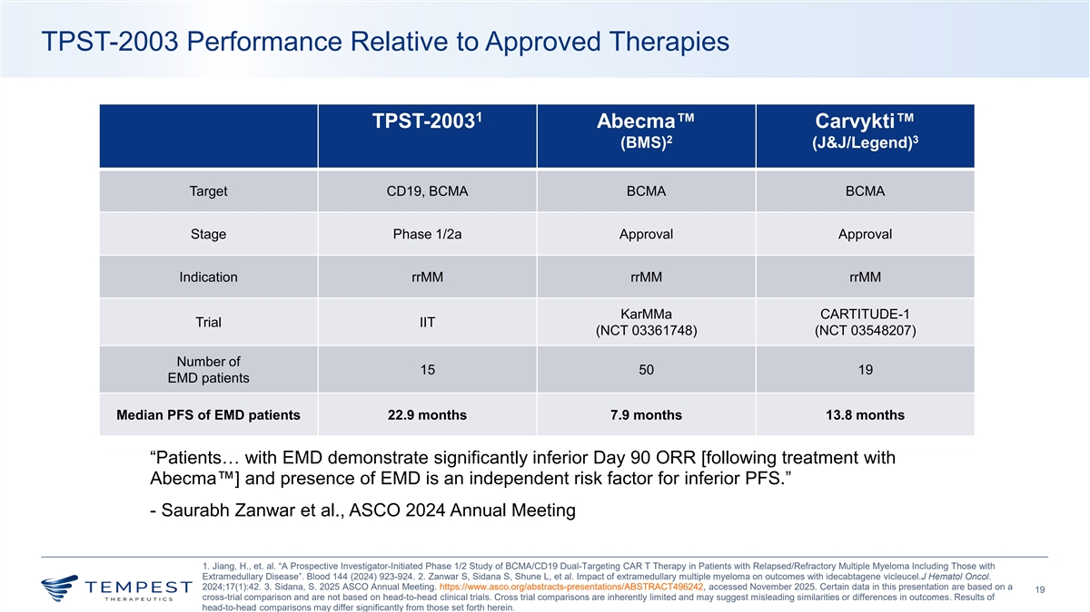
TPST-2003 Performance Relative to Approved Therapies 1 TPST-2003 Abecma Carvykti 2 3 (BMS) (J&J/Legend) Target CD19, BCMA BCMA BCMA Stage Phase 1/2a Approval Approval Indication rrMM rrMM rrMM KarMMa CARTITUDE-1 Trial IIT (NCT 03361748) (NCT 03548207) Number of 15 50 19 EMD patients Median PFS of EMD patients 22.9 months 7.9 months 13.8 months “Patients… with EMD demonstrate significantly inferior Day 90 ORR [following treatment with Abecma ] and presence of EMD is an independent risk factor for inferior PFS.” - Saurabh Zanwar et al., ASCO 2024 Annual Meeting 1. Jiang, H., et. al. “A Prospective Investigator-Initiated Phase 1/2 Study of BCMA/CD19 Dual-Targeting CAR T Therapy in Patients with Relapsed/Refractory Multiple Myeloma Including Those with Extramedullary Disease”. Blood 144 (2024) 923-924. 2. Zanwar S, Sidana S, Shune L, et al. Impact of extramedullary multiple myeloma on outcomes with idecabtagene vicleucel.J Hematol Oncol. 2024;17(1):42. 3. Sidana, S. 2025 ASCO Annual Meeting. https://www.asco.org/abstracts-presentations/ABSTRACT496242, accessed November 2025. Certain data in this presentation are based on a 19 cross-trial comparison and are not based on head-to-head clinical trials. Cross trial comparisons are inherently limited and may suggest misleading similarities or differences in outcomes. Results of head-to-head comparisons may differ significantly from those set forth herein.

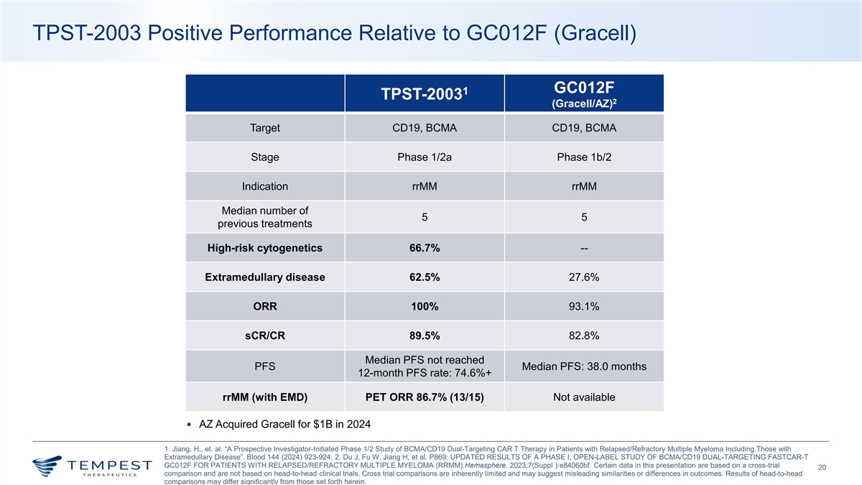
TPST-2003 Positive Performance Relative to GC012F (Gracell) GC012F 1 TPST-2003 2 (Gracell/AZ) Target CD19, BCMA CD19, BCMA Stage Phase 1/2a Phase 1b/2 Indication rrMM rrMM Median number of 5 5 previous treatments High-risk cytogenetics 66.7% -- Extramedullary disease 62.5% 27.6% ORR 100% 93.1% sCR/CR 89.5% 82.8% Median PFS not reached PFS Median PFS: 38.0 months 12-month PFS rate: 74.6%+ rrMM (with EMD) PET ORR 86.7% (13/15) Not available • AZ Acquired Gracell for $1B in 2024 1. Jiang, H., et. al. “A Prospective Investigator-Initiated Phase 1/2 Study of BCMA/CD19 Dual-Targeting CAR T Therapy in Patients with Relapsed/Refractory Multiple Myeloma Including Those with Extramedullary Disease”. Blood 144 (2024) 923-924. 2. Du J, Fu W, Jiang H, et al. P869: UPDATED RESULTS OF A PHASE I, OPEN-LABEL STUDY OF BCMA/CD19 DUAL-TARGETING FASTCAR-T GC012F FOR PATIENTS WITH RELAPSED/REFRACTORY MULTIPLE MYELOMA (RRMM).Hemasphere. 2023;7(Suppl ):e84060bf. Certain data in this presentation are based on a cross-trial 20 comparison and are not based on head-to-head clinical trials. Cross trial comparisons are inherently limited and may suggest misleading similarities or differences in outcomes. Results of head-to-head comparisons may differ significantly from those set forth herein.

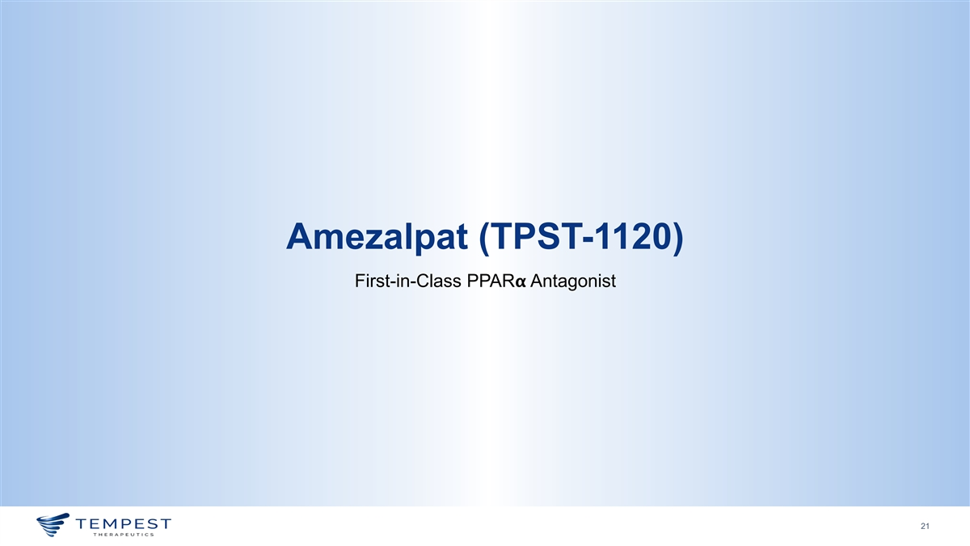
Amezalpat (TPST-1120) First-in-Class PPAR𝝰𝝰 Antagonist 21

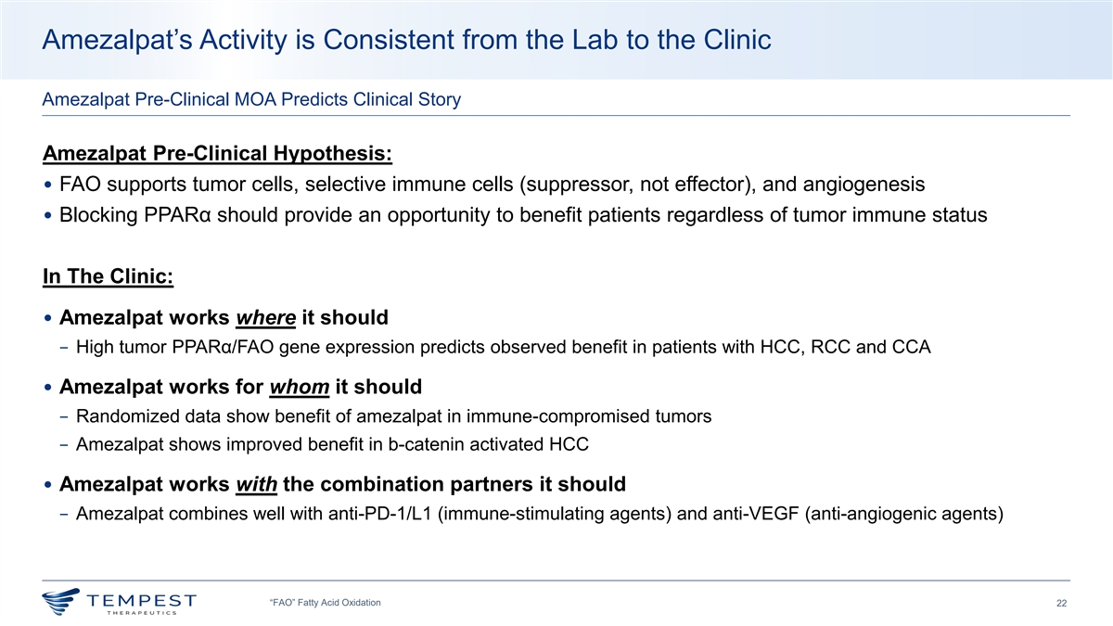
Amezalpat’s Activity is Consistent from the Lab to the Clinic Amezalpat Pre-Clinical MOA Predicts Clinical Story Amezalpat Pre-Clinical Hypothesis: • FAO supports tumor cells, selective immune cells (suppressor, not effector), and angiogenesis • Blocking PPARα should provide an opportunity to benefit patients regardless of tumor immune status In The Clinic: • Amezalpat works where it should − High tumor PPARα/FAO gene expression predicts observed benefit in patients with HCC, RCC and CCA • Amezalpat works for whom it should − Randomized data show benefit of amezalpat in immune-compromised tumors − Amezalpat shows improved benefit in b-catenin activated HCC • Amezalpat works with the combination partners it should − Amezalpat combines well with anti-PD-1/L1 (immune-stimulating agents) and anti-VEGF (anti-angiogenic agents) “FAO” Fatty Acid Oxidation 22

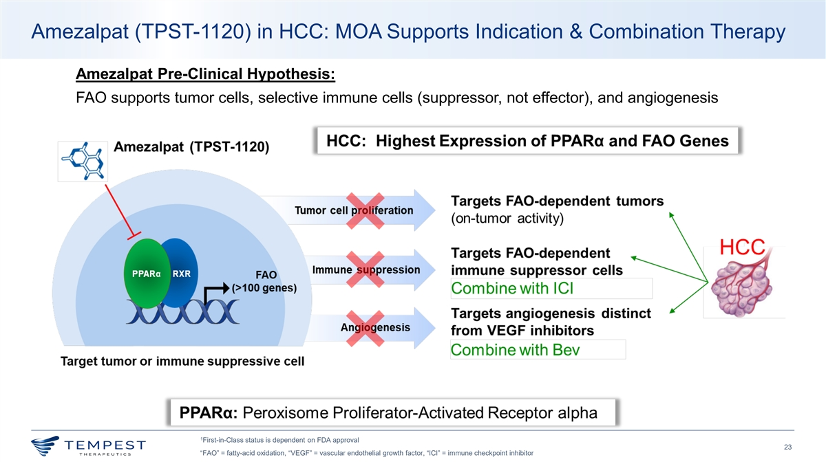
Amezalpat (TPST-1120) in HCC: MOA Supports Indication & Combination Therapy Amezalpat Pre-Clinical Hypothesis: FAO supports tumor cells, selective immune cells (suppressor, not effector), and angiogenesis 1 First-in-Class status is dependent on FDA approval 23 “FAO” = fatty-acid oxidation, “VEGF” = vascular endothelial growth factor, “ICI” = immune checkpoint inhibitor

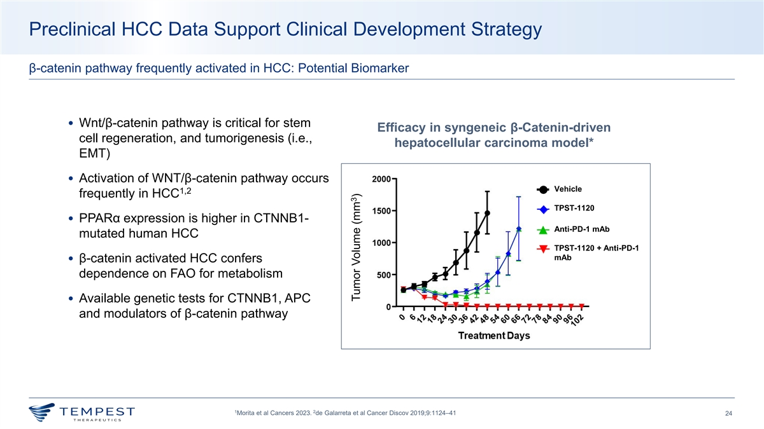
Preclinical HCC Data Support Clinical Development Strategy β-catenin pathway frequently activated in HCC: Potential Biomarker • Wnt/β-catenin pathway is critical for stem Efficacy in syngeneic β-Catenin-driven cell regeneration, and tumorigenesis (i.e., hepatocellular carcinoma model* EMT) • Activation of WNT/β-catenin pathway occurs Vehicle 1,2 frequently in HCC TPST-1120 • PPARα expression is higher in CTNNB1- Anti-PD-1 mAb mutated human HCC TPST-1120 + Anti-PD-1 mAb • β-catenin activated HCC confers dependence on FAO for metabolism • Available genetic tests for CTNNB1, APC and modulators of β-catenin pathway 1 2 Morita et al Cancers 2023. de Galarreta et al Cancer Discov 2019;9:1124–41 24 3 Tumor Volume (mm )

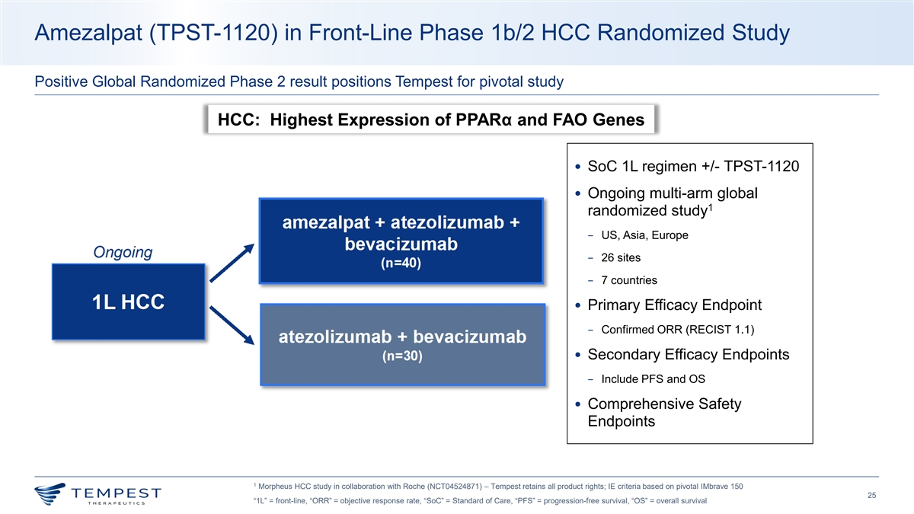
Amezalpat (TPST-1120) in Front-Line Phase 1b/2 HCC Randomized Study Positive Global Randomized Phase 2 result positions Tempest for pivotal study HCC: Highest Expression of PPARα and FAO Genes • SoC 1L regimen +/- TPST-1120 • Ongoing multi-arm global 1 randomized study − US, Asia, Europe − 26 sites − 7 countries • Primary Efficacy Endpoint − Confirmed ORR (RECIST 1.1) • Secondary Efficacy Endpoints − Include PFS and OS • Comprehensive Safety Endpoints 1 Morpheus HCC study in collaboration with Roche (NCT04524871) – Tempest retains all product rights; IE criteria based on pivotal IMbrave 150 25 “1L” = front-line, “ORR” = objective response rate, “SoC” = Standard of Care, “PFS” = progression-free survival, “OS” = overall survival

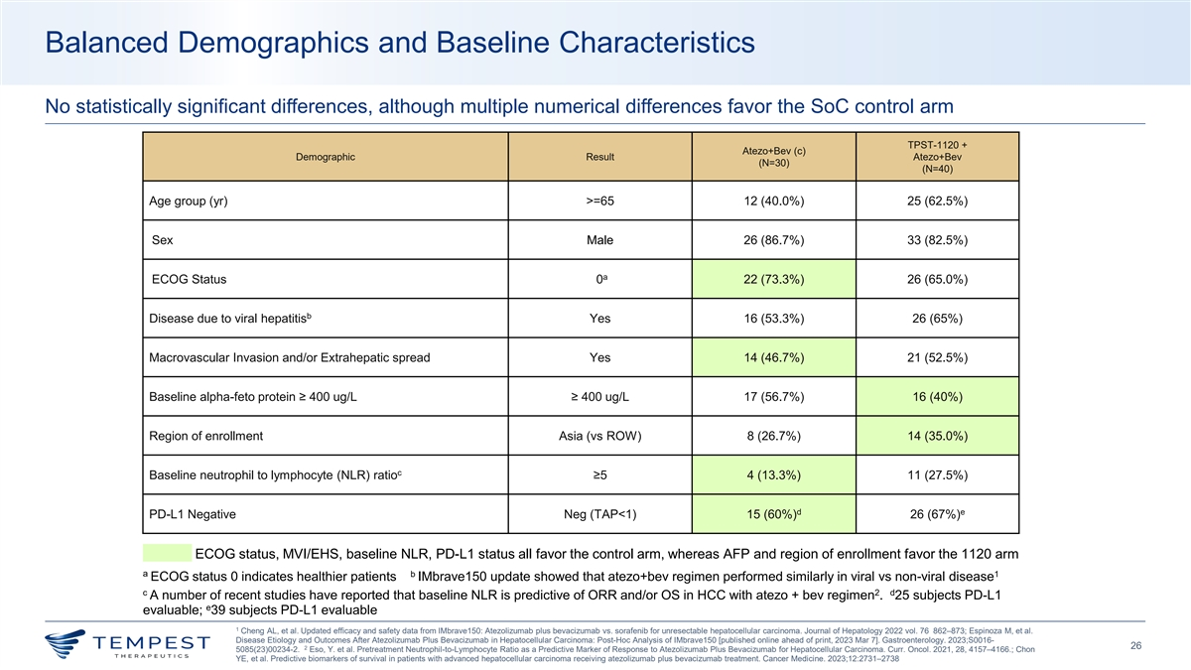
Balanced Demographics and Baseline Characteristics No statistically significant differences, although multiple numerical differences favor the SoC control arm TPST-1120 + Atezo+Bev (c) Demographic Result Atezo+Bev (N=30) (N=40) Age group (yr) >=65 12 (40.0%) 25 (62.5%) Sex Male 26 (86.7%) 33 (82.5%) a ECOG Status 0 22 (73.3%) 26 (65.0%) b Disease due to viral hepatitis Yes 16 (53.3%) 26 (65%) Macrovascular Invasion and/or Extrahepatic spread Yes 14 (46.7%) 21 (52.5%) Baseline alpha-feto protein ≥ 400 ug/L ≥ 400 ug/L 17 (56.7%) 16 (40%) Region of enrollment Asia (vs ROW) 8 (26.7%) 14 (35.0%) c Baseline neutrophil to lymphocyte (NLR) ratio ≥5 4 (13.3%) 11 (27.5%) d e PD-L1 Negative Neg (TAP<1) 15 (60%) 26 (67%) ECOG status, MVI/EHS, baseline NLR, PD-L1 status all favor the control arm, whereas AFP and region of enrollment favor the 1120 arm a b 1 ECOG status 0 indicates healthier patients IMbrave150 update showed that atezo+bev regimen performed similarly in viral vs non-viral disease c 2 d A number of recent studies have reported that baseline NLR is predictive of ORR and/or OS in HCC with atezo + bev regimen . 25 subjects PD-L1 e evaluable; 39 subjects PD-L1 evaluable 1 Cheng AL, et al. Updated efficacy and safety data from IMbrave150: Atezolizumab plus bevacizumab vs. sorafenib for unresectable hepatocellular carcinoma. Journal of Hepatology 2022 vol. 76 862–873; Espinoza M, et al. Disease Etiology and Outcomes After Atezolizumab Plus Bevacizumab in Hepatocellular Carcinoma: Post-Hoc Analysis of IMbrave150 [published online ahead of print, 2023 Mar 7]. Gastroenterology. 2023;S0016- 26 2 5085(23)00234-2. Eso, Y. et al. Pretreatment Neutrophil-to-Lymphocyte Ratio as a Predictive Marker of Response to Atezolizumab Plus Bevacizumab for Hepatocellular Carcinoma. Curr. Oncol. 2021, 28, 4157–4166.; Chon YE, et al. Predictive biomarkers of survival in patients with advanced hepatocellular carcinoma receiving atezolizumab plus bevacizumab treatment. Cancer Medicine. 2023;12:2731–2738

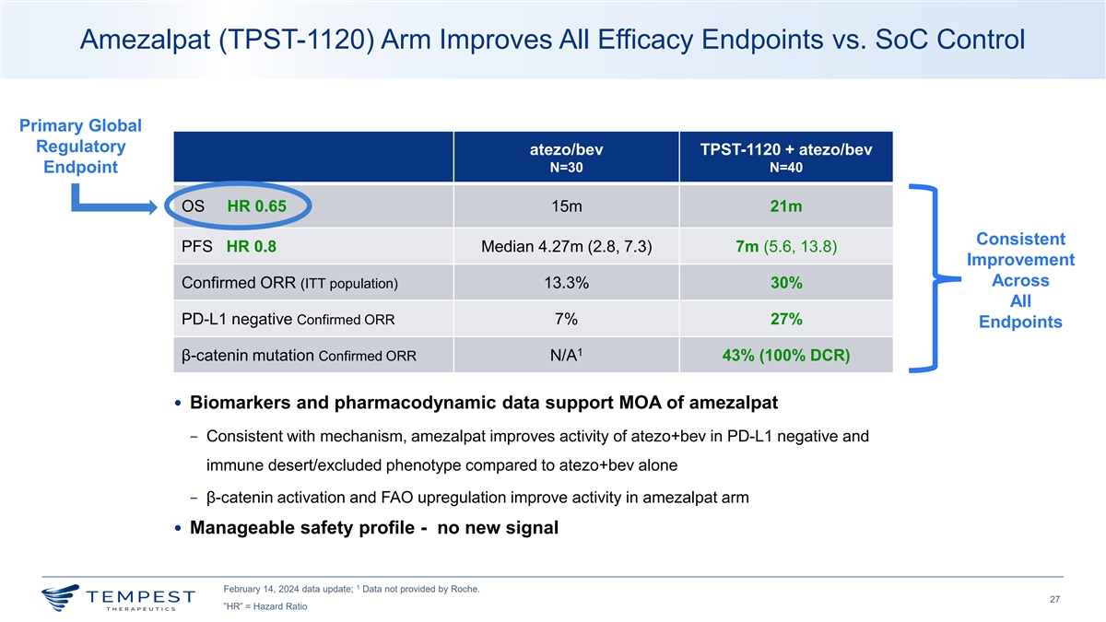
Amezalpat (TPST-1120) Arm Improves All Efficacy Endpoints vs. SoC Control Primary Global Regulatory atezo/bev TPST-1120 + atezo/bev Endpoint N=30 N=40 OS HR 0.65 15m 21m Consistent PFS HR 0.8 Median 4.27m (2.8, 7.3) 7m (5.6, 13.8) Improvement Across Confirmed ORR (ITT population) 13.3% 30% All PD-L1 negative Confirmed ORR 7% 27% Endpoints 1 β-catenin mutation Confirmed ORR N/A 43% (100% DCR) • Biomarkers and pharmacodynamic data support MOA of amezalpat − Consistent with mechanism, amezalpat improves activity of atezo+bev in PD-L1 negative and immune desert/excluded phenotype compared to atezo+bev alone − β-catenin activation and FAO upregulation improve activity in amezalpat arm • Manageable safety profile - no new signal 1 February 14, 2024 data update; Data not provided by Roche. 27 ”HR” = Hazard Ratio

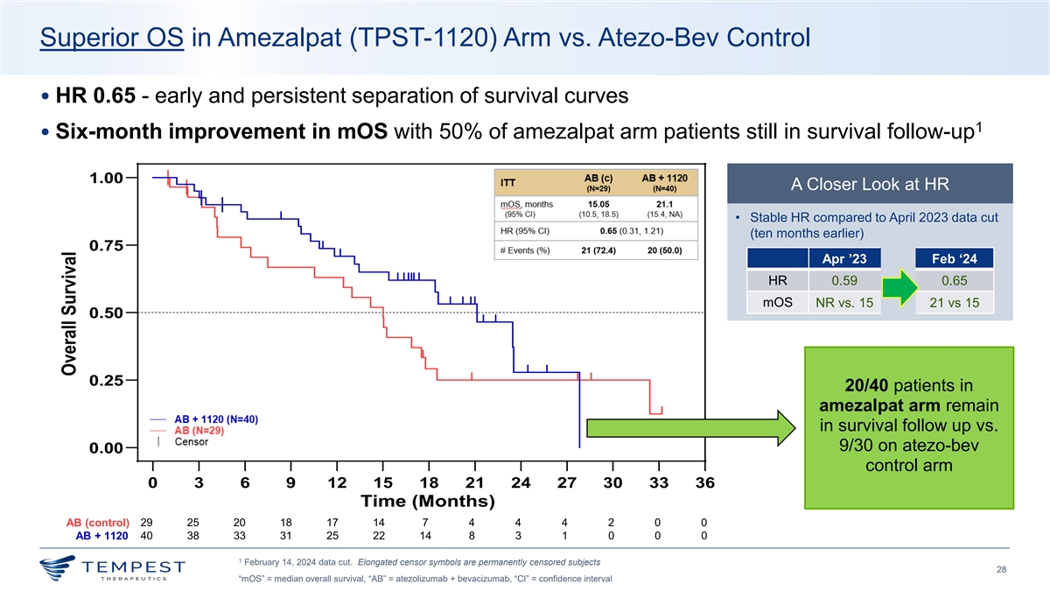
Superior OS in Amezalpat (TPST-1120) Arm vs. Atezo-Bev Control • HR 0.65 - early and persistent separation of survival curves 1 • Six-month improvement in mOS with 50% of amezalpat arm patients still in survival follow-up 1.00 A Closer Look at HR • Stable HR compared to April 2023 data cut (ten months earlier) 0.75 Apr ’23 Feb ‘24 HR 0.59 0.65 mOS NR vs. 15 21 vs 15 0.50 0.25 20/40 patients in amezalpat arm remain in survival follow up vs. 9/30 on atezo-bev 0.00 control arm 0 3 6 9 12 15 18 21 24 27 30 33 36 Time (Months) AB (control) 29 25 20 18 17 14 7 4 4 4 2 0 0 AB + 1120 40 38 33 31 25 22 14 8 3 1 0 0 0 1 February 14, 2024 data cut. Elongated censor symbols are permanently censored subjects 28 “mOS” = median overall survival, “AB” = atezolizumab + bevacizumab, “CI” = confidence interval Overall Survival

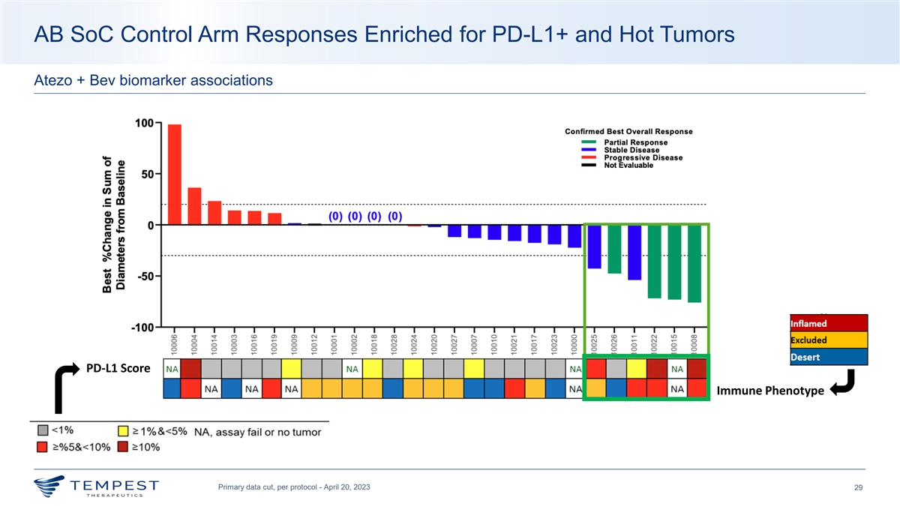
AB SoC Control Arm Responses Enriched for PD-L1+ and Hot Tumors Atezo + Bev biomarker associations PD-L1 Score Immune Phenotype Primary data cut, per protocol - April 20, 2023 29

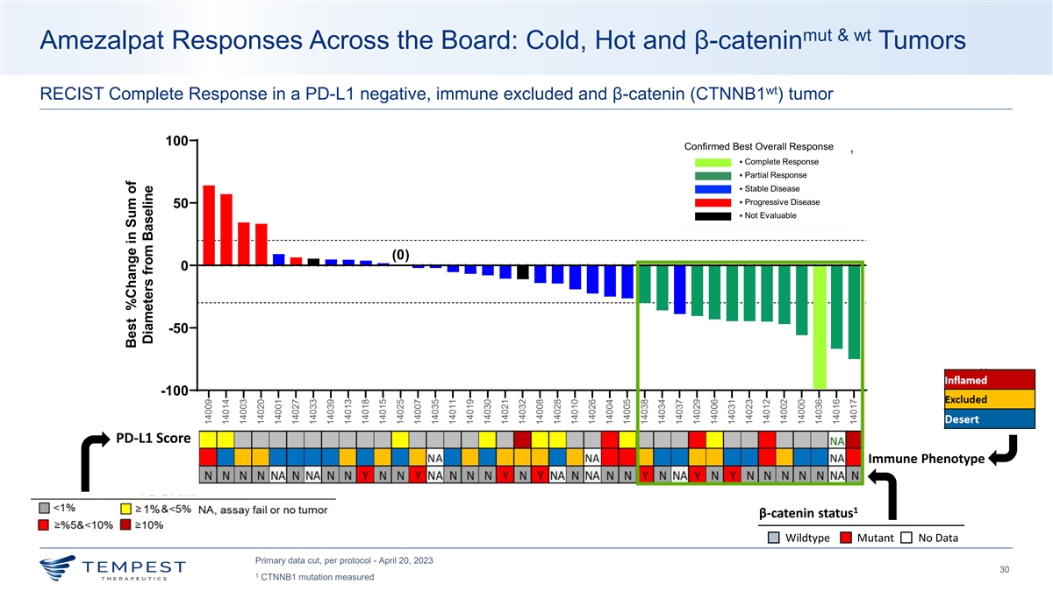
mut & wt Amezalpat Responses Across the Board: Cold, Hot and β-catenin Tumors wt RECIST Complete Response in a PD-L1 negative, immune excluded and β-catenin (CTNNB1 ) tumor 100 Confirmed Best Overall Response Partial Response Stable Disease Progressive Disease Not Evaluable 50 (0) 0 -50 -100 PD-L1 Score Immune Phenotype 1 β-catenin status Wildtype Mutant No Data Primary data cut, per protocol - April 20, 2023 30 1 CTNNB1 mutation measured Best %Change in Sum of Diameters from Baseline 14009 14014 14003 14020 14001 14027 14033 14039 14013 14018 14015 14025 14007 14035 14011 14019 14030 14021 14032 14008 14028 14010 14026 14004 14005 14038 14034 14037 14029 14006 14031 14023 14012 14002 14000 14036 14016 14017

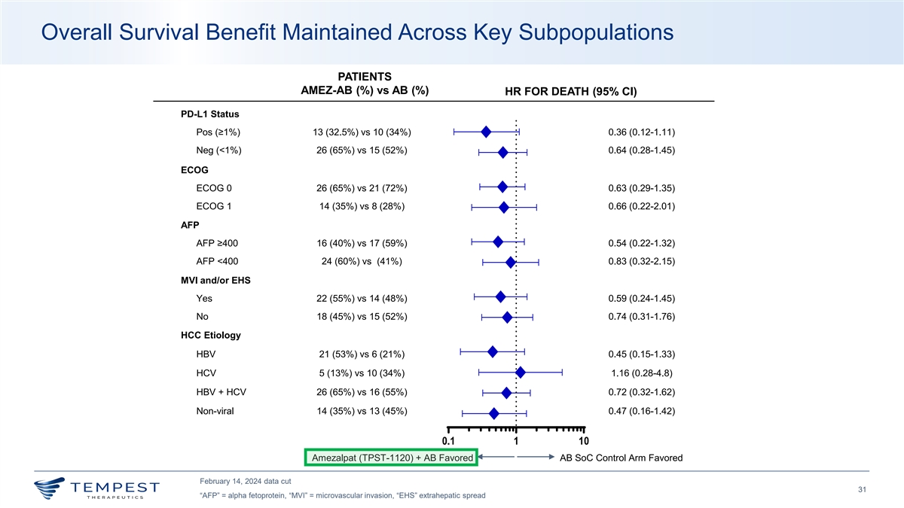
Overall Survival Benefit Maintained Across Key Subpopulations PATIENTS AMEZ-AB (%) vs AB (%) HR FOR DEATH (95% CI) PD-L1 Status Pos (≥1%) 13 (32.5%) vs 10 (34%) 0.36 (0.12-1.11) Neg (<1%) 26 (65%) vs 15 (52%) 0.64 (0.28-1.45) ECOG ECOG 0 26 (65%) vs 21 (72%) 0.63 (0.29-1.35) ECOG 1 14 (35%) vs 8 (28%) 0.66 (0.22-2.01) AFP AFP ≥400 16 (40%) vs 17 (59%) 0.54 (0.22-1.32) AFP <400 24 (60%) vs (41%) 0.83 (0.32-2.15) MVI and/or EHS Yes 22 (55%) vs 14 (48%) 0.59 (0.24-1.45) No 18 (45%) vs 15 (52%) 0.74 (0.31-1.76) HCC Etiology HBV 21 (53%) vs 6 (21%) 0.45 (0.15-1.33) HCV 5 (13%) vs 10 (34%) 1.16 (0.28-4.8) HBV + HCV 26 (65%) vs 16 (55%) 0.72 (0.32-1.62) Non-viral 14 (35%) vs 13 (45%) 0.47 (0.16-1.42) 0.1 1 10 Amezalpat (TPST-1120) + AB Favored AB SoC Control Arm Favored February 14, 2024 data cut 31 “AFP” = alpha fetoprotein, “MVI” = microvascular invasion, “EHS” extrahepatic spread

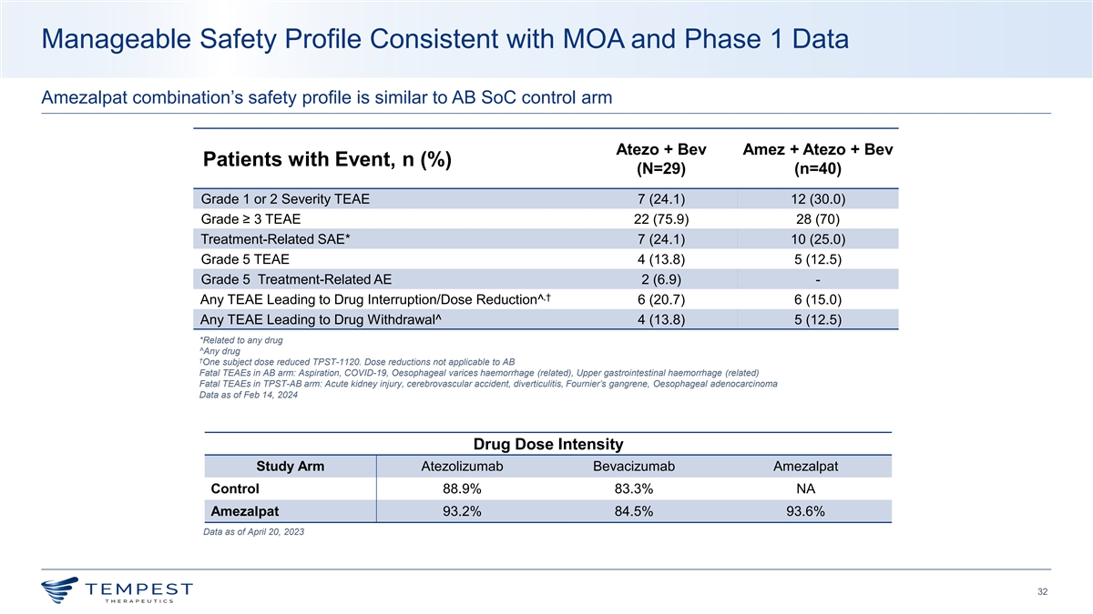
Manageable Safety Profile Consistent with MOA and Phase 1 Data Amezalpat combination’s safety profile is similar to AB SoC control arm Atezo + Bev Amez + Atezo + Bev Patients with Event, n (%) (N=29) (n=40) Grade 1 or 2 Severity TEAE 7 (24.1) 12 (30.0) Grade ≥ 3 TEAE 22 (75.9) 28 (70) Treatment-Related SAE* 7 (24.1) 10 (25.0) Grade 5 TEAE 4 (13.8) 5 (12.5) Grade 5 Treatment-Related AE 2 (6.9) - ,† Any TEAE Leading to Drug Interruption/Dose Reduction^ 6 (20.7) 6 (15.0) Any TEAE Leading to Drug Withdrawal^ 4 (13.8) 5 (12.5) *Related to any drug ^Any drug † One subject dose reduced TPST-1120. Dose reductions not applicable to AB Fatal TEAEs in AB arm: Aspiration, COVID-19, Oesophageal varices haemorrhage (related), Upper gastrointestinal haemorrhage (related) Fatal TEAEs in TPST-AB arm: Acute kidney injury, cerebrovascular accident, diverticulitis, Fournier’s gangrene, Oesophageal adenocarcinoma Data as of Feb 14, 2024 Drug Dose Intensity Study Arm Atezolizumab Bevacizumab Amezalpat Control 88.9% 83.3% NA Amezalpat 93.2% 84.5% 93.6% Data as of April 20, 2023 32

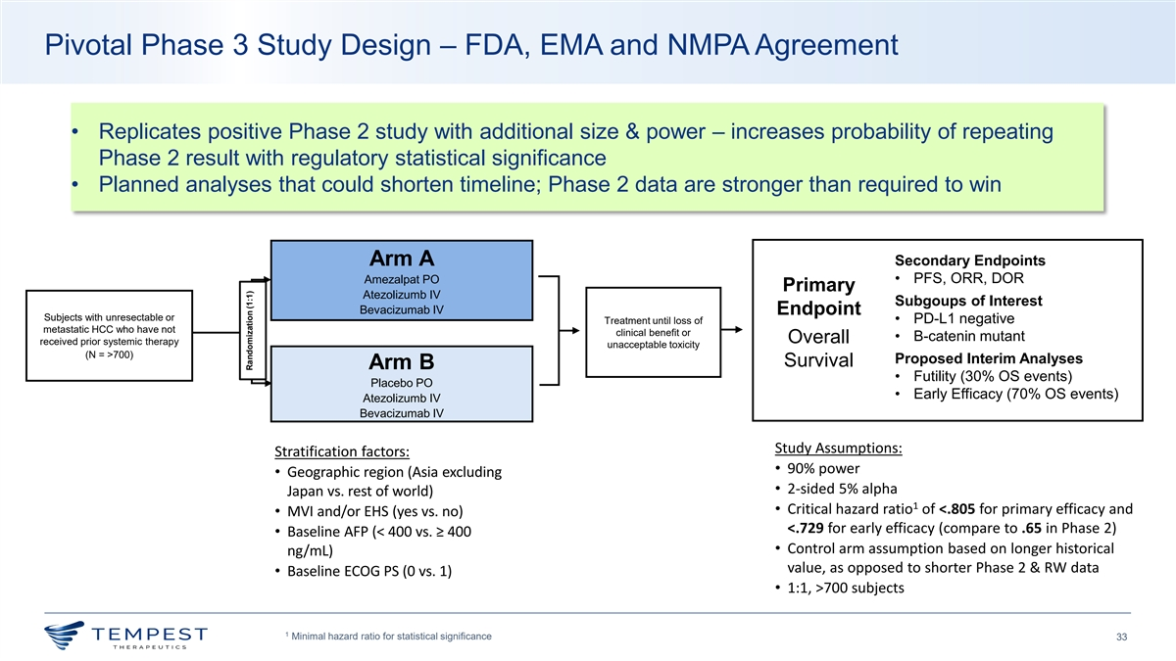
Pivotal Phase 3 Study Design – FDA, EMA and NMPA Agreement • Replicates positive Phase 2 study with additional size & power – increases probability of repeating Phase 2 result with regulatory statistical significance • Planned analyses that could shorten timeline; Phase 2 data are stronger than required to win Arm A Secondary Endpoints • PFS, ORR, DOR Amezalpat PO Primary Atezolizumb IV Subgoups of Interest Bevacizumab IV Endpoint Subjects with unresectable or • PD-L1 negative Treatment until loss of metastatic HCC who have not clinical benefit or • B-catenin mutant Overall received prior systemic therapy unacceptable toxicity (N = >700) Proposed Interim Analyses Survival Arm B • Futility (30% OS events) Placebo PO • Early Efficacy (70% OS events) Atezolizumb IV Bevacizumab IV Study Assumptions: Stratification factors: • 90% power • Geographic region (Asia excluding • 2-sided 5% alpha Japan vs. rest of world) 1 • Critical hazard ratio of <.805 for primary efficacy and • MVI and/or EHS (yes vs. no) <.729 for early efficacy (compare to .65 in Phase 2) • Baseline AFP (< 400 vs. ≥ 400 • Control arm assumption based on longer historical ng/mL) value, as opposed to shorter Phase 2 & RW data • Baseline ECOG PS (0 vs. 1) • 1:1, >700 subjects 1 Minimal hazard ratio for statistical significance 33 Randomization (1:1)

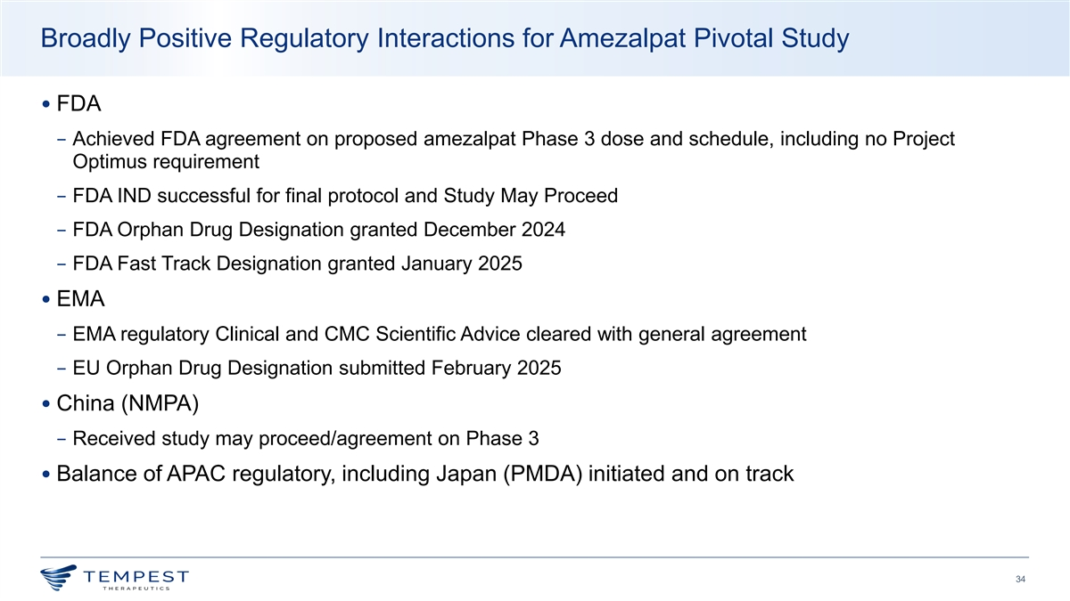
Broadly Positive Regulatory Interactions for Amezalpat Pivotal Study • FDA − Achieved FDA agreement on proposed amezalpat Phase 3 dose and schedule, including no Project Optimus requirement − FDA IND successful for final protocol and Study May Proceed − FDA Orphan Drug Designation granted December 2024 − FDA Fast Track Designation granted January 2025 • EMA − EMA regulatory Clinical and CMC Scientific Advice cleared with general agreement − EU Orphan Drug Designation submitted February 2025 • China (NMPA) − Received study may proceed/agreement on Phase 3 • Balance of APAC regulatory, including Japan (PMDA) initiated and on track 34

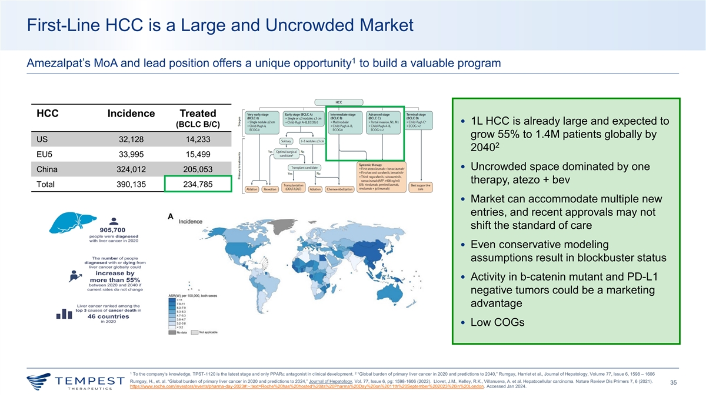
First-Line HCC is a Large and Uncrowded Market 1 Amezalpat’s MoA and lead position offers a unique opportunity to build a valuable program HCC Incidence Treated • 1L HCC is already large and expected to (BCLC B/C) grow 55% to 1.4M patients globally by US 32,128 14,233 2 2040 EU5 33,995 15,499 • Uncrowded space dominated by one China 324,012 205,053 therapy, atezo + bev Total 390,135 234,785 • Market can accommodate multiple new entries, and recent approvals may not shift the standard of care • Even conservative modeling assumptions result in blockbuster status • Activity in b-catenin mutant and PD-L1 negative tumors could be a marketing advantage • Low COGs 1 2 To the company’s knowledge, TPST-1120 is the latest stage and only PPAR⍺ antagonist in clinical development. “Global burden of primary liver cancer in 2020 and predictions to 2040,” Rumgay, Harriet et al., Journal of Hepatology, Volume 77, Issue 6, 1598 – 1606 Rumgay, H., et. al. “Global burden of primary liver cancer in 2020 and predictions to 2024,” Journal of Hepatology, Vol. 77, Issue 6, pg: 1598-1606 (2022). Llovet, J.M., Kelley, R.K., Villanueva, A. et al. Hepatocellular carcinoma. Nature Review Dis Primers 7, 6 (2021). 35 https://www.roche.com/investors/events/pharma-day-2023#:~:text=Roche%20has%20hosted%20its%20Pharma%20Day%20on%2011th%20September%202023%20in%20London. Accessed Jan 2024.

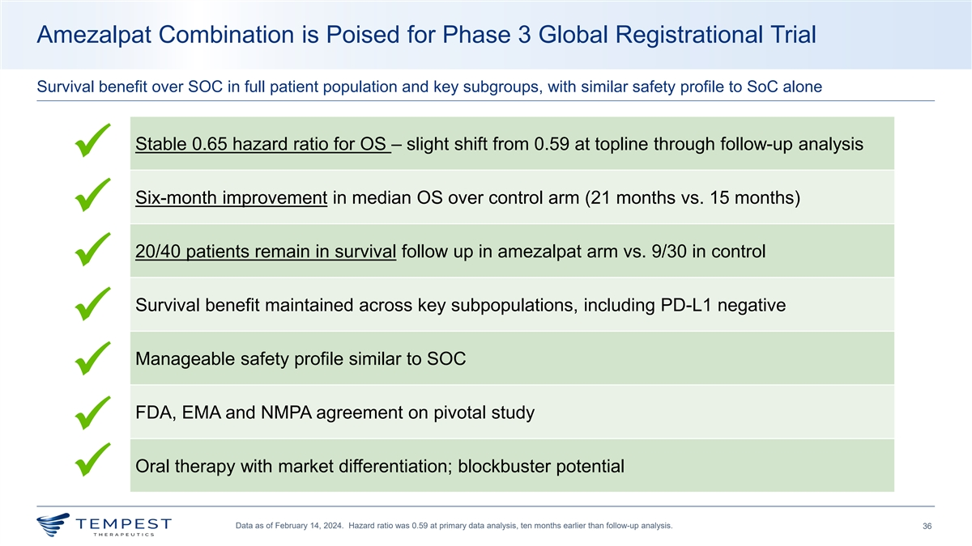
Amezalpat Combination is Poised for Phase 3 Global Registrational Trial Survival benefit over SOC in full patient population and key subgroups, with similar safety profile to SoC alone Stable 0.65 hazard ratio for OS – slight shift from 0.59 at topline through follow-up analysis ü Six-month improvement in median OS over control arm (21 months vs. 15 months) ü 20/40 patients remain in survival follow up in amezalpat arm vs. 9/30 in control ü Survival benefit maintained across key subpopulations, including PD-L1 negative ü Manageable safety profile similar to SOC ü FDA, EMA and NMPA agreement on pivotal study ü Oral therapy with market differentiation; blockbuster potential ü Data as of February 14, 2024. Hazard ratio was 0.59 at primary data analysis, ten months earlier than follow-up analysis. 36

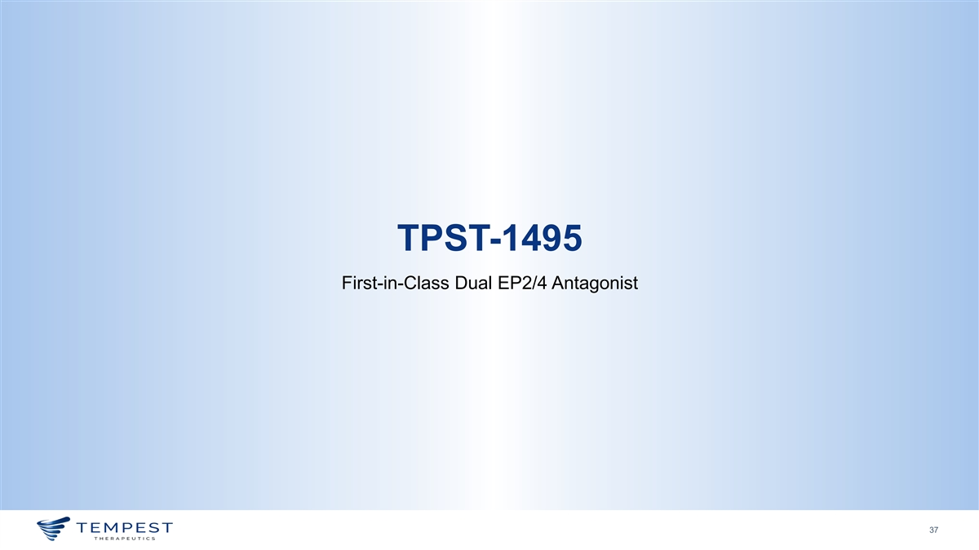
TPST-1495 First-in-Class Dual EP2/4 Antagonist 37

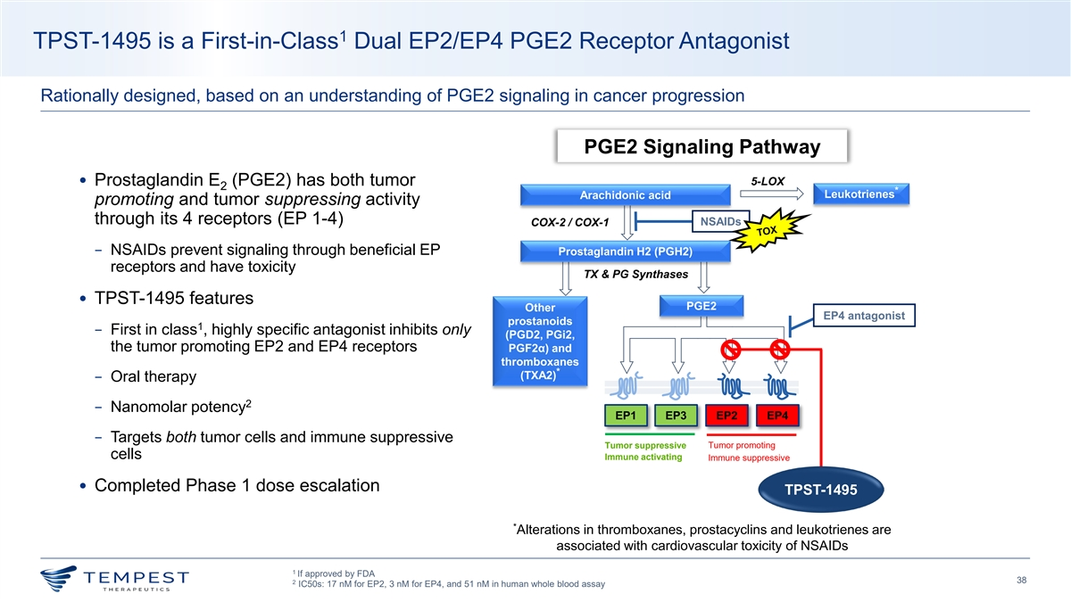
1 TPST-1495 is a First-in-Class Dual EP2/EP4 PGE2 Receptor Antagonist Rationally designed, based on an understanding of PGE2 signaling in cancer progression PGE2 Signaling Pathway 5-LOX • Prostaglandin E (PGE2) has both tumor 2 * Leukotrienes Arachidonic acid * promoting and tumor suppressing activity through its 4 receptors (EP 1-4) NSAIDs COX-2 / COX-1 − NSAIDs prevent signaling through beneficial EP Prostaglandin H2 (PGH2) receptors and have toxicity TX & PG Synthases • TPST-1495 features PGE2 Other EP4 antagonist prostanoids 1 − First in class , highly specific antagonist inhibits only (PGD2, PGi2, the tumor promoting EP2 and EP4 receptors PGF2α) and thromboxanes * (TXA2) − Oral therapy 2 − Nanomolar potency EP1 EP3 EP2 EP4 − Targets both tumor cells and immune suppressive Tumor suppressive Tumor promoting cells Immune activating Immune suppressive • Completed Phase 1 dose escalation TPST-1495 * Alterations in thromboxanes, prostacyclins and leukotrienes are associated with cardiovascular toxicity of NSAIDs 1 If approved by FDA 38 2 IC50s: 17 nM for EP2, 3 nM for EP4, and 51 nM in human whole blood assay TOX

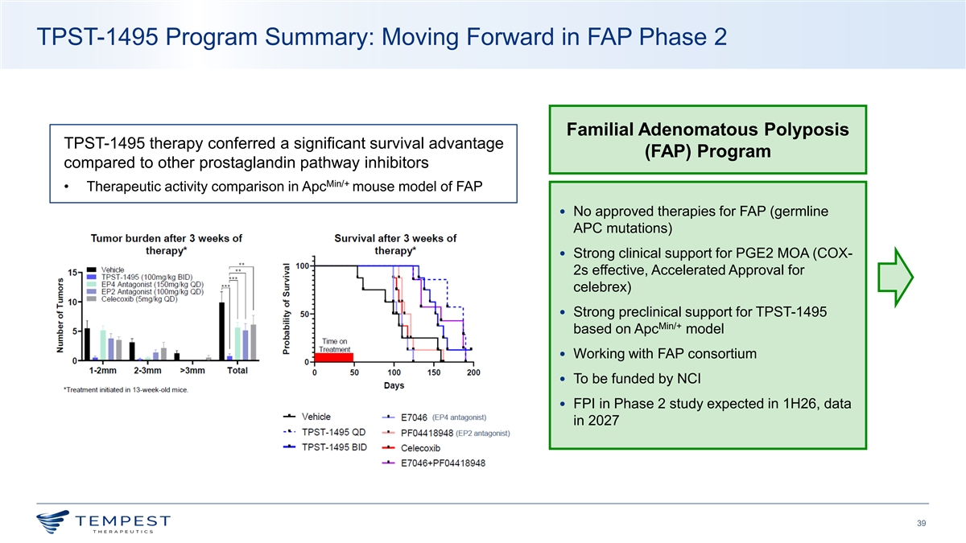
TPST-1495 Program Summary: Moving Forward in FAP Phase 2 Familial Adenomatous Polyposis TPST-1495 therapy conferred a significant survival advantage (FAP) Program compared to other prostaglandin pathway inhibitors Min/+ • Therapeutic activity comparison in Apc mouse model of FAP • No approved therapies for FAP (germline APC mutations) • Strong clinical support for PGE2 MOA (COX- 2s effective, Accelerated Approval for celebrex) • Strong preclinical support for TPST-1495 Min/+ based on Apc model • Working with FAP consortium • To be funded by NCI • FPI in Phase 2 study expected in 1H26, data in 2027 39


® Accelerating the Development of Advanced Therapies for Cancer Patients February 2026

