United States
Securities and Exchange Commission
Washington, D.C. 20549

SCHEDULE 14A
Proxy Statement Pursuant to Section 14(a) of the
Securities Exchange Act of 1934

Filed by the Registrant ☒ Filed by a Party other than the Registrant ☐
Check the appropriate box:

☐ | Preliminary Proxy Statement

☐ | Confidential, for Use of the Commission Only (as permitted by Rule 14a-6(e)(2))

☐ | Definitive Proxy Statement

☒ | Definitive Additional Materials

☐ | Soliciting Material under § 240.14a-12
Tempest Therapeutics, Inc.
(Name of Registrant as Specified In Its Charter)
(Name of Person(s) Filing Proxy Statement if other than the Registrant)
Payment of Filing Fee (Check all boxes that apply):

☒ | No fee required.

☐ | Fee paid previously with preliminary materials

☐ | Fee computed on table in exhibit required by Item 25(b) per Exchange Act Rules 14a-6(i)(1) and 0-11

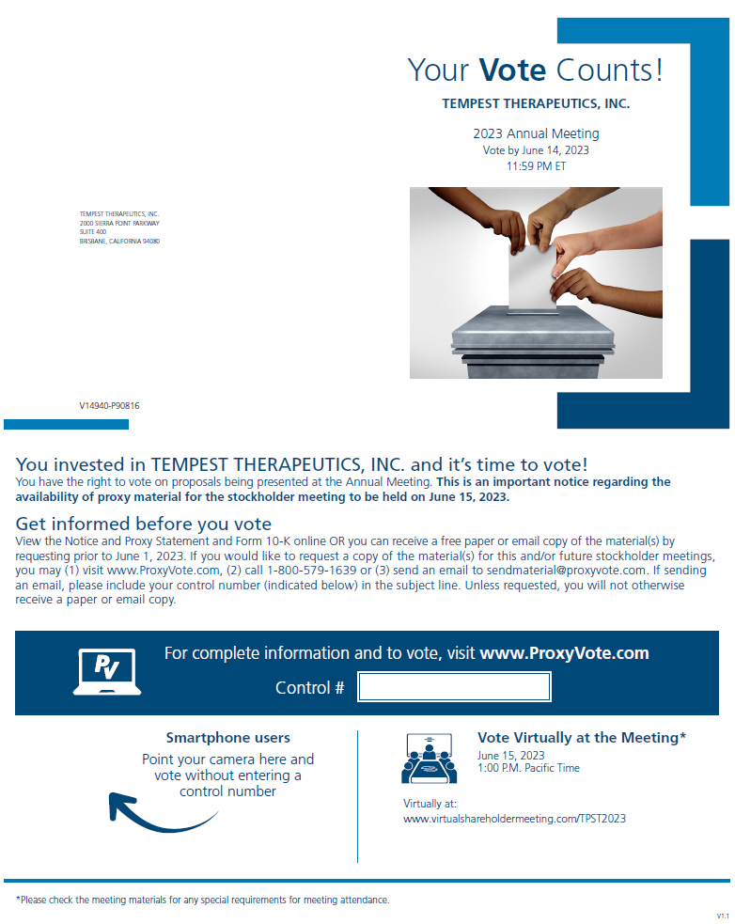
Your Vote Counts! TEMPEST THERAPEUTICS, INC. 2023 Annual Meeting Vote by June 14, 2023 11:59 PM ET TEMPEST THERAPEUTICS, INC. 2000 SIERRA POINT PARKWAY SUITE 400 BRISBANE, CALIFORNIA 94080 V14940-P90816 You invested in TEMPEST THERAPEUTICS, INC. and its time to vote! You have the right to vote on proposals being presented at the Annual Meeting. This is an important notice regarding the availability of proxy material for the stockholder meeting to be held on June 15, 2023. Get informed before you vote View the Notice and Proxy Statement and Form 10-K online OR you can receive a free paper or email copy of the material(s) by requesting prior to June 1, 2023. If you would like to request a copy of the material(s) for this and/or future stockholder meetings, you may (1) visit www.ProxyVote.com, (2) call 1-800-579-1639 or (3) send an email to sendmaterial@proxyvote.com. If sending an email, please include your control number (indicated below) in the subject line. Unless requested, you will not otherwise receive a paper or email copy. For complete information and to vote, visit www.ProxyVote.com Control # Smartphone users Point your camera here and vote without entering a control number Vote Virtually at the Meeting* June 15, 2023 1:00 P.M. Pacific Time Virtually at: www.virtualshareholdermeeting.com/TPST2023 *Please check the meeting materials for any special requirements for meeting attendance. V1.1

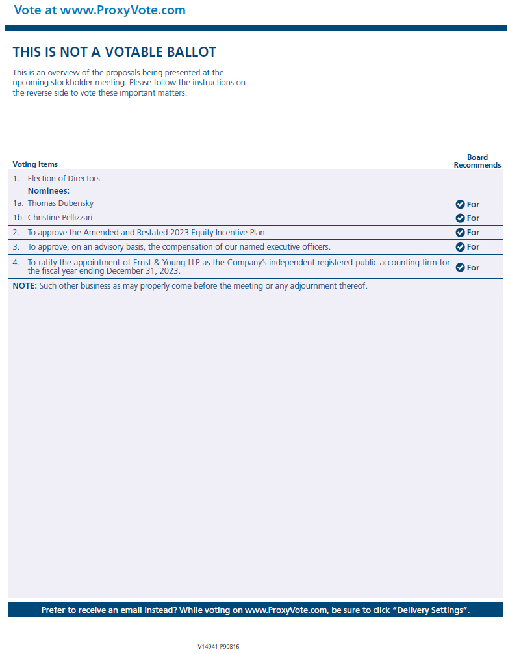
Vote at www.ProxyVote.com THIS IS NOT A VOTABLE BALLOT This is an overview of the proposals being presented at the upcoming stockholder meeting. Please follow the instructions on the reverse side to vote these important matters. Voting Items 1. Election of Directors Nominees: 1a. Thomas Dubensky 1b. Christine Pellizzari 2. To approve the Amended and Restated 2023 Equity Incentive Plan. 3. To approve, on an advisory basis, the compensation of our named executive officers. 4. To ratify the appointment of Ernst & Young LLP as the Companys independent registered public accounting firm for the fiscal year ending December 31, 2023. NOTE: Such other business as may properly come before the meeting or any adjournment thereof. Board Recommends For Prefer to receive an email instead? While voting on www.ProxyVote.com, be sure to click Delivery Settings. V14941-P90816

