UNITED STATES

SECURITIES AND EXCHANGE COMMISSION
WASHINGTON, D.C. 20549

FORM 8-K

CURRENT REPORT

PURSUANT TO SECTION 13 OR 15(D)
OF THE SECURITIES EXCHANGE ACT OF 1934

Date of Report (Date of earliest event reported): March 29, 2022

TEMPEST THERAPEUTICS, INC.

(Exact name of Registrant as Specified in its Charter)

Delaware | 001-35890 | 45-1472564
(State or other jurisdiction | (Commission | (IRS Employer
of incorporation) | File Number) | Identification No.)
 | 7000 Shoreline Court, Suite 275
 | South San Francisco, CA 94080
 | (Address of principal executive offices) (Zip Code)
 | Registrant’s telephone number, including area code: (415) 798-8589
 | N/A
 | (Former Name or Former Address, if Changed Since Last Report)

Check the appropriate box below if the Form 8-K filing is intended to simultaneously satisfy the filing obligation of the registrant under any of the following provisions (see General Instruction A.2. below):

- Written communications pursuant to Rule 425 under the Securities Act (17 CFR 230.425)

- Soliciting material pursuant to Rule 14a-12 under the Exchange Act (17 CFR 240.14a-12)

- Pre-commencement communications pursuant to Rule 14d-2(b) under the Exchange Act (17 CFR 240.14d-2(b))

- Pre-commencement communications pursuant to Rule 13e-4(c) under the Exchange Act (17 CFR 240.13e-4(c))

Securities registered pursuant to Section 12(b) of the Act:

 | Trading | Name of each exchange
Title of each class | Symbol(s) | on which registered
Common Stock, par value $0.001 per share | TPST | The Nasdaq Stock Market

Indicate by check mark whether the registrant is an emerging growth company as defined in Rule 405 of the Securities Act of 1933 (§230.405 of this chapter) or Rule 12b-2 of the Securities Exchange Act of 1934 (§240.12b-2 of this chapter).

Emerging growth company ☐

If an emerging growth company, indicate by check mark if the registrant has elected not to use the extended transition period for complying with any new or revised financial accounting standards provided pursuant to Section 13(a) of the Exchange Act. ☐

Item 2.02 Results of Operations and Financial Condition.

On March 29, 2022, Tempest Therapeutics, Inc. (the “Company”) issued a press release announcing its financial results for the year ended December 31, 2021. A copy of the Company’s press release dated March 29, 2022, titled “Tempest Reports Year End 2021 Financial Results and Provides Corporate Highlights” is attached hereto as Exhibit 99.1 and is incorporated herein by reference.

The foregoing information (including the exhibit hereto) is being furnished under “Item 2.02 Results of Operations and Financial Condition” and shall not be deemed “filed” for purposes of Section 18 of the Securities Exchange Act of 1934, as amended, nor shall it be deemed incorporated by reference in any filing under the Securities Act of 1933, as amended, except as shall be expressly set forth by specific reference in such filing.

Item 9.01 Financial Statements and Exhibits.

(d) Exhibits.

Exhibit No. | Description
99.1 |  | Press release dated March 29, 2021
104 |  | Cover Page Interactive Data File (embedded within the Inline XBRL document)

SIGNATURES

Pursuant to the requirements of the Securities Exchange Act of 1934, as amended, the Registrant has duly caused this report to be signed on its behalf by the undersigned hereunto duly authorized.

TEMPEST THERAPEUTICS, INC.

Date: March 29, 2022

By:

/s/ Stephen Brady

Name:

Title:

Stephen Brady

Chief Executive Officer

Exhibit 99.1


Tempest Reports Year End 2021 Financial Results and

Provides Corporate Highlights

- First clinical data presentation planned for ASCO: TPST-1120 Phase 1 monotherapy and combination dose escalation and optimization arms

- TPST-1120 randomized study in first-line HCC patients with partner Roche is ongoing, with initial data expected by YE22/early 2023

- TPST-1495 Phase 1 monotherapy and combination dose escalation and optimization ongoing, with data expected by YE22/early 2023

- First public presentation of preclinical efficacy results of proprietary small molecule TREX1 inhibitors planned for AACR

South San Francisco, CA, March 29, 2022 – Tempest Therapeutics, Inc. (Nasdaq: TPST), a clinical-stage oncology company developing first-in-class¹ therapeutics that combine both targeted and immune-mediated mechanisms, today reported financial results for the year ended December 31, 2021 and provided a corporate update.

“We are excited by the numerous achievements the Tempest team made in 2021, including emerging as a public company from a competitive merger process and establishing the collaboration with Roche that moved TPST-1120 into a first-line global, randomized HCC study,” said Stephen R. Brady, chief executive officer of Tempest. “This and the broader progress made in the pipeline positions Tempest for a potentially transformative 2022. Our first clinical data presentation planned for ASCO in June is the first in a series of planned data releases over the course of the next 12-18 months, including initial ORR data from both our ongoing randomized TPST-1120 study with our partner Roche and the first monotherapy and combination therapy data from TPST-1495, our dual EP2/EP4 antagonist. We are excited about this ongoing positive evolution of Tempest, and we will continue to work to develop what we believe to be is a robust and diversified pipeline of novel cancer programs with the potential to treat a wide range of patients.”

Recent Highlights

- TPST-1120 (clinical PPARα antagonist): (i) completed Phase 1 monotherapy arm and nearing completion of the anti-PD-1 checkpoint inhibitor, nivolumab, combination dose escalation arms, and selected recommended Phase 2 dose (“RP2D”); and (ii) continued enrollment in first-line, randomized global Phase 1b/2 study in patients with hepatocellular carcinoma (HCC), under a collaboration with F. Hoffmann La Roche.

- TPST-1495 (clinical dual EP2/4 prostaglandin receptor antagonist): (i) continued enrollment in a Phase 1 study evaluating monotherapy dose and schedule optimization towards establishing an RP2D; and (ii) commenced enrollment of a study evaluating combination dose and schedule optimization study with the anti-PD-1 checkpoint inhibitor, pembrolizumab.

¹If approved by the FDA

1

- SITC Presentation: at the Society for Immunotherapy of Cancer’s (SITC) 36th Annual Meeting, presented new preclinical efficacy data demonstrating that dual inhibition pf the EP2 and EP4 receptors with TPST-1495 is an optimal approach for targeting the prostaglandin pathway in cancer.

- Expansion of Patent Portfolio: the U.S. Patent and Trademark Office issued patents covering composition of matter for our therapeutic product candidate TPST-1495.

Planned Near-Term Milestones

- TPST-1120 (clinical PPARα antagonist): (i) if accepted to present, presentation of Phase 1 monotherapy and combination data at ASCO 2022; and (ii) reporting of objective response data from the first 40 HCC patients in the first-line randomized study expected by year end or early 2023.

- TPST-1495 (clinical dual EP2/4 prostaglandin receptor antagonist): (i) selection of monotherapy RP2D expected in the first half of 2022; and (ii) data from Phase 1 monotherapy and combination dose and schedule optimization arms expected by year end or early 2023.

- TREX1 Inhibitor (preclinical tumor-selective STING pathway activator): (i) presentation of the first data demonstrating therapeutic benefit in tumor-bearing mice treated with systemically-administered proprietary targeted molecules at the American Association for Cancer Research (AACR) 2022 Annual Meeting; and (ii) planned selection of development candidate in the second half of 2022.

Financial Results

Year End 2021

- Tempest ended the year 2021 with $51.8 million in cash and cash equivalents, compared to $18.8 million at December 31, 2020. The increase was primarily due to the merger and concurrent PIPE financing, which closed in June 2021.

- Net cash used in operations for the year ended December 31, 2021 was $26.0 million.

- Net loss and net loss per share for the year ended December 31, 2021 were $28.3 million and $7.47, respectively, compared to $19.2 million and $41.03, respectively, for the same period in 2020.

- Research and development expenses for the year ended December 31, 2021 were $17.2 million compared to $14.4 million for the same period in 2020. The $2.8 million increase was primarily attributable to expanded research and development efforts and increased fees for consulting services and compensation expenses.

- For the year ended December 31, 2021, general and administrative expenses were $9.8 million compared to $4.9 million for the same period in 2020. The increase of $4.9 million was primarily due to increased fees for audit and tax services and compensation expenses.

- Based on current cash position and operating plan, Tempest expects to have sufficient resources to fund operations into the second half of 2023.

About Tempest Therapeutics

Tempest Therapeutics is a clinical-stage oncology company advancing small molecules that combine both tumor-targeted and immune-mediated mechanisms with the potential to treat a wide range of tumors. The company’s two novel clinical programs are TPST-1120 and TPST-1495, antagonists of PPARα and EP2/EP4, respectively. Both TPST-1120 and TPST-1495 are advancing through Phase 1 clinical trials designed to study both agents as monotherapies and in combination with other approved agents. In collaboration with F. Hoffmann La Roche, TPST-1120 is also advancing in a randomized, global, Phase 1b/2 clinical study in combination with the standard-of-care regimen of atezolizumab and bevacizumab in the first-line treatment of patients with advanced or metastatic hepatocellular carcinoma. Tempest is also developing an orally-available inhibitor of TREX-1 designed to activate

2

selectively the cGAS/STING pathway, an innate immune response pathway important for the development of anti-tumor immunity. Tempest is headquartered in South San Francisco. More information about Tempest can be found on the company’s website at www.tempesttx.com.

Forward-Looking Statements

This press release contains forward-looking statements (including within the meaning of Section 21E of the Securities Exchange Act of 1934, as amended, and Section 27A of the Securities Act of 1933, as amended (the “Securities Act”)) concerning Tempest Therapeutics, Inc. (“Tempest Therapeutics”). These statements may discuss goals, intentions, and expectations as to future plans, trends, events, results of operations or financial condition, or otherwise, based on current beliefs of the management of Tempest Therapeutics, as well as assumptions made by, and information currently available to, management of Tempest Therapeutics. Forward-looking statements generally include statements that are predictive in nature and depend upon or refer to future events or conditions, and include words such as “may,” “will,” “should,” “would,” “could”, “expect,” “anticipate,” “plan,” “likely,” “believe,” “estimate,” “project,” “intend,” and other similar expressions. All statements that are not historical facts are forward-looking statements, including any statements regarding the timing and selection of development candidates, dose selection or commencement of, or availability of data from, clinical trials, the company’s guidance regarding cash resources, as well as our operational plans and the timing and ability to deliver on value-creating milestones. Forward-looking statements are based on information available to Tempest Therapeutics as of the date hereof and are not guarantees of future performance. Actual results could differ materially from those contained in any forward-looking statement. These and other risks are described in greater detail in the Form 10-K filed by Tempest Therapeutics with the Securities and Exchange Commission on March 29, 2022. Except as required by applicable law, Tempest Therapeutics undertakes no obligation to revise or update any forward-looking statement, or to make any other forward-looking statements, whether as a result of new information, future events or otherwise. These forward-looking statements should not be relied upon as representing Tempest Therapeutics’ views as of any date subsequent to the date of this press release and should not be relied upon as prediction of future events. In light of the foregoing, investors are urged not to rely on any forward-looking statement in reaching any conclusion or making any investment decision about any securities of Tempest Therapeutics.

3

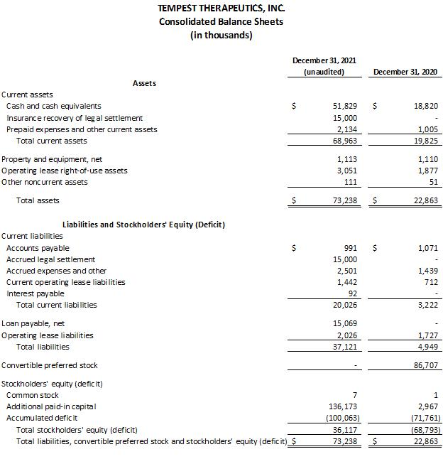

4

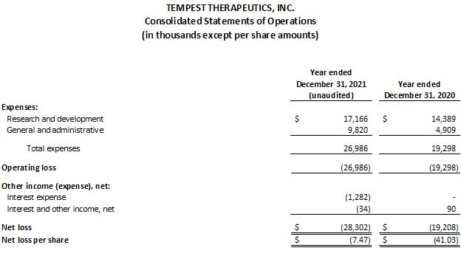

Investor Contacts:
Sylvia Wheeler
Wheelhouse Life Science Advisors

swheeler@wheelhouselsa.com

Aljanae Reynolds
Wheelhouse Life Science Advisors
areynolds@wheelhouselsa.com

5

