UNITED STATES
SECURITIES AND EXCHANGE COMMISSION
WASHINGTON, D.C. 20549
FORM 8-K
CURRENT REPORT
PURSUANT TO SECTION 13 OR 15(D)
OF THE SECURITIES EXCHANGE ACT OF 1934
Date of Report (Date of earliest event reported): May 13, 2022
TEMPEST THERAPEUTICS, INC.
(Exact name of Registrant as Specified in its Charter)

Delaware |  |  | 001-35890 |  |  | 45-1472564
(State or other jurisdiction  of incorporation) |  |  | (Commission  File Number) |  |  | (IRS Employer  Identification No.)
7000 Shoreline Court, Suite 275
South San Francisco, CA 94080
(Address of principal executive offices) (Zip Code)
Registrant’s telephone number, including area code: (415) 798-8589
N/A
(Former Name or Former Address, if Changed Since Last Report)
Check the appropriate box below if the Form 8-K filing is intended to simultaneously satisfy the filing obligation of the registrant under any of the following provisions (see General Instruction A.2. below):
☐ Written communications pursuant to Rule 425 under the Securities Act (17 CFR 230.425)
☐ Soliciting material pursuant to Rule 14a-12 under the Exchange Act (17 CFR 240.14a-12)
☐ Pre-commencement communications pursuant to Rule 14d-2(b) under the Exchange Act (17 CFR 240.14d-2(b))
☐ Pre-commencement communications pursuant to Rule 13e-4(c) under the Exchange Act (17 CFR 240.13e-4(c))
Securities registered pursuant to Section 12(b) of the Act:

Title of each class |  |  | Trading  Symbol(s) |  |  | Name of each exchange  on which registered
Common Stock, par value $0.001 per share |  |  | TPST |  |  | The Nasdaq Stock Market
Indicate by check mark whether the registrant is an emerging growth company as defined in Rule 405 of the Securities Act of 1933 (§230.405 of this chapter) or Rule 12b-2 of the Securities Exchange Act of 1934 (§240.12b-2 of this chapter).
Emerging growth company ☐

If an emerging growth company, indicate by check mark if the registrant has elected not to use the extended transition period for complying with any new or revised financial accounting standards provided pursuant to Section 13(a) of the Exchange Act. ☐

Item 2.02 Results of Operations and Financial Condition.

On May 13, 2022, Tempest Therapeutics, Inc. (the “Company”) issued a press release announcing its financial results for the quarter ended March 31, 2022. A copy of the Company’s press release dated May 13, 2022, titled “Tempest Reports First Quarter 2022 Financial Results and Provides Corporate Highlights” is attached hereto as Exhibit 99.1 and is incorporated herein by reference.

The foregoing information (including the exhibit hereto) is being furnished under “Item 2.02 Results of Operations and Financial Condition” and shall not be deemed “filed” for purposes of Section 18 of the Securities Exchange Act of 1934, as amended, nor shall it be deemed incorporated by reference in any filing under the Securities Act of 1933, as amended, except as shall be expressly set forth by specific reference in such filing.
Item 9.01 Financial Statements and Exhibits.
(d) Exhibits.

Exhibit No. |  |  | Description
99.1 |  |  | Press release dated May 13, 2022
104 |  |  | Cover Page Interactive Data File (embedded within the Inline XBRL document)

SIGNATURES
Pursuant to the requirements of the Securities Exchange Act of 1934, as amended, the Registrant has duly caused this report to be signed on its behalf by the undersigned hereunto duly authorized.

 |  |  |  |  |  | TEMPEST THERAPEUTICS, INC.
Date: May 13, 2022 |  |  |  |  |  | By: |  |  | /s/ Stephen Brady
 |  |  |  |  |  | Name: |  |  | Stephen Brady
 |  |  |  |  |  | Title: |  |  | Chief Executive Officer

Exhibit 99.1



Tempest Reports First Quarter 2022 Financial Results and
Provides Corporate Highlights

•Announced oral presentation of TPST-1120 Phase 1 monotherapy and combination therapy data at ASCO

•Presented positive preclinical data for TPST-1495 at AACR

•Presented positive preclinical data with proprietary small molecule TREX1 inhibitors at AACR

South San Francisco, CA, May 13, 2022 – Tempest Therapeutics, Inc. (Nasdaq: TPST), a clinical-stage oncology company developing first-in-class1 therapeutics that combine both targeted and immune-mediated mechanisms, today reported financial results for the quarter ended March 31, 2022 and provided a corporate update.

“The team continued to execute well throughout the first quarter of this year, enabling us to present the first clinical data from a Tempest program at the ASCO Annual Meeting in June,” said Stephen R. Brady, chief executive officer of Tempest. “We look forward to the upcoming oral presentation, which will highlight the clinical profile and responses observed in the monotherapy and combination Phase 1 study of TPST-1120, our novel PPARa antagonist.”

Recent Highlights

•TPST-1120 (clinical PPARα antagonist): (i) completed enrollment in the Phase 1 monotherapy and combination dose escalation arms; (ii) announced that the American Society of Clinical Oncology (ASCO) accepted for an oral presentation at its 2022 Annual Meeting an abstract containing the TPST-1120 Phase 1 monotherapy and combination data; and (iii) continued enrollment in first-line, randomized global Phase 1b/2 study in patients with hepatocellular carcinoma (HCC), under a collaboration with F. Hoffmann La Roche.

•TPST-1495 (clinical dual EP2/4 prostaglandin receptor antagonist): (i) continued enrollment in a Phase 1 study evaluating both monotherapy and combination (with anti-PD-1 checkpoint inhibitor, pembrolizumab) dose and schedule optimization arms, towards establishing an RP2D; (ii) presented preclinical data further differentiating TPST-1495 from other approaches targeting the prostaglandin E2 (PGE2) pathway at the American Association for Cancer Research (AACR) 2022 Annual Meeting; and (ii) announced that ASCO accepted for a poster presentation a “trials in progress” for the ongoing TPST-1495 Phase 1 clinical monotherapy and combination therapy clinical trial.

•TREX1 Inhibitor (preclinical tumor-selective STING pathway activator): presented the first data with proprietary targeted molecules demonstrating therapeutic benefit in tumor-bearing mice at the AACR 2022 Annual Meeting.

Planned Near-Term Milestones

•TPST-1120 (clinical PPARα antagonist): (i) first presentation of clinical data from a Tempest program at the oral presentation of the Phase 1 monotherapy and combination data at the ASCO 2022 Annual Meeting;
1If approved by the FDA
1
and (ii) objective response data from the first 40 HCC patients in the first-line randomized study expected by year end or early 2023.

•TPST-1495 (clinical dual EP2/4 prostaglandin receptor antagonist): (i) selection of monotherapy RP2D expected in the first half of 2022; (ii) presentation of “trial in progress” poster at ASCO 2022 Annual Meeting; and (iii) data from Phase 1 monotherapy and combination dose and schedule optimization arms expected by year end or early 2023.

•TREX1 Inhibitor (preclinical tumor-selective STING pathway activator): planned selection of development candidate in the second half of 2022.

PIPE Financing

•On April 27, we announced a $15 million private investment in public equity (PIPE) financing to EcoR1 Capital, LLC and Versant Venture Capital.

Financial Results

First Quarter

•Tempest ended the first quarter of 2022 with $45.8 million in cash and cash equivalents, compared to $51.8 million at December 31, 2021. The decrease was primarily due to cash used in operations of $7.1 million offset by proceeds from sales under our ATM program of $1.4 million. Cash balance does not reflect $15 million raised in April from PIPE financing.

•Net cash used in operations for the quarter ended March 31, 2022 was $7.1 million compared to $6.3 million for the same period in 2021.

•Net loss and net loss per share for the quarter ended March 31, 2022 were $8.5 million and $1.18, respectively, compared to $5.4 million and $10.55, respectively, for the first quarter of 2021.

•Research and development expenses for the first quarter of 2022 were $5.1 million compared to $3.6 million for the same period in 2021. The $1.5 million increase was primarily attributable to expanded research and development efforts and increased fees for consulting services and compensation expenses.

•For the three months ended March 31, 2022, general and administrative expenses were $3.0 million compared to $1.5 million for the same period in 2021. The increase of $1.5 million was primarily due to higher professional and consulting fees, insurance, and compensation expenses.

About Tempest Therapeutics

Tempest Therapeutics is a clinical-stage oncology company advancing small molecules that combine both tumor-targeted and immune-mediated mechanisms with the potential to treat a wide range of tumors. The company’s two novel clinical programs are TPST-1120 and TPST-1495, antagonists of PPARα and EP2/EP4, respectively. Both TPST-1120 and TPST-1495 are advancing through Phase 1 clinical trials designed to study both agents as monotherapies and in combination with other approved agents. In collaboration with F. Hoffmann La Roche, TPST-1120 is also advancing in a randomized, global, Phase 1b/2 clinical study in combination with the standard-of-care regimen of atezolizumab and bevacizumab in the first-line treatment of patients with advanced or metastatic hepatocellular carcinoma. Tempest is also developing an orally-available inhibitor of TREX-1 designed to activate selectively the cGAS/STING pathway, an innate immune response pathway important for the development of anti-tumor immunity. Tempest is headquartered in South San Francisco. More information about Tempest can be found on the company’s website at www.tempesttx.com.

Forward-Looking Statements

This press release contains forward-looking statements (including within the meaning of Section 21E of the Securities Exchange Act of 1934, as amended, and Section 27A of the Securities Act of 1933, as amended (the
2
“Securities Act”)) concerning Tempest Therapeutics, Inc. (“Tempest Therapeutics”). These statements may discuss goals, intentions, and expectations as to future plans, trends, events, results of operations or financial condition, or otherwise, based on current beliefs of the management of Tempest Therapeutics, as well as assumptions made by, and information currently available to, management of Tempest Therapeutics. Forward-looking statements generally include statements that are predictive in nature and depend upon or refer to future events or conditions, and include words such as “may,” “will,” “should,” “would,” “could”, “expect,” “anticipate,” “plan,” “likely,” “believe,” “estimate,” “project,” “intend,” and other similar expressions. All statements that are not historical facts are forward-looking statements, including any statements regarding the timing and selection of development candidates, dose selection or commencement of, or availability of data from, clinical trials, the company’s guidance regarding cash resources, as well as our operational plans and the timing and ability to deliver on value-creating milestones. Forward-looking statements are based on information available to Tempest Therapeutics as of the date hereof and are not guarantees of future performance. Actual results could differ materially from those contained in any forward-looking statement. These and other risks are described in greater detail in the Form 10-K filed by Tempest Therapeutics with the Securities and Exchange Commission on March 29, 2022. Except as required by applicable law, Tempest Therapeutics undertakes no obligation to revise or update any forward-looking statement, or to make any other forward-looking statements, whether as a result of new information, future events or otherwise. These forward-looking statements should not be relied upon as representing Tempest Therapeutics’ views as of any date subsequent to the date of this press release and should not be relied upon as prediction of future events. In light of the foregoing, investors are urged not to rely on any forward-looking statement in reaching any conclusion or making any investment decision about any securities of Tempest Therapeutics.

3
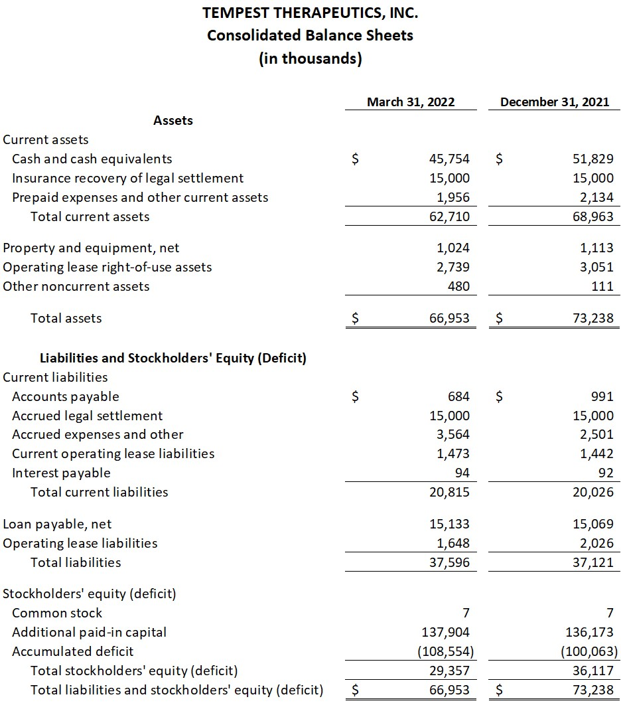

4
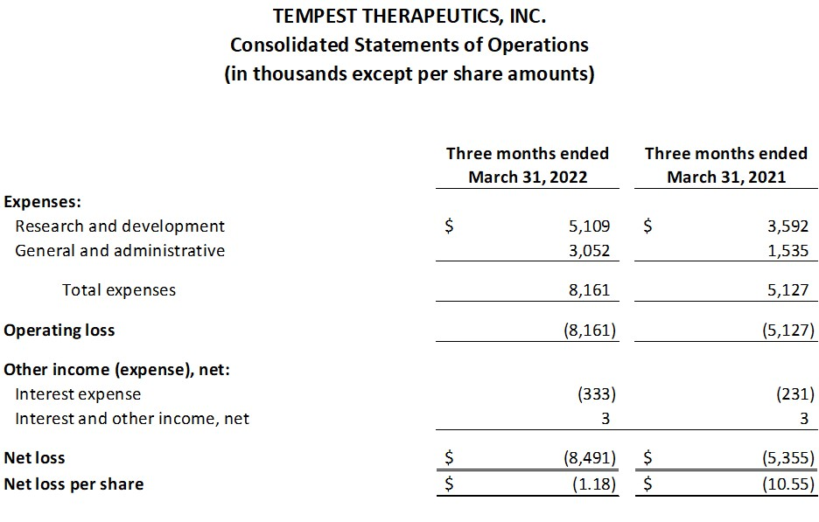

Investor Contacts:
Sylvia Wheeler
Wheelhouse Life Science Advisors
swheeler@wheelhouselsa.com

Aljanae Reynolds
Wheelhouse Life Science Advisors
areynolds@wheelhouselsa.com
5

