UNITED STATES

SECURITIES AND EXCHANGE COMMISSION

WASHINGTON, D.C. 20549

FORM 8-K

CURRENT REPORT

PURSUANT TO SECTION 13 OR 15(D)
OF THE SECURITIES EXCHANGE ACT OF 1934

Date of Report (Date of earliest event reported): August 15, 2022

TEMPEST THERAPEUTICS, INC.

(Exact name of Registrant as Specified in its Charter)

Delaware | 001-35890 | 45-1472564
(State or other jurisdiction | (Commission | (IRS Employer
of incorporation) | File Number) | Identification No.)
 | 7000 Shoreline Court, Suite 275
 | South San Francisco, CA 94080
 | (Address of principal executive offices) (Zip Code)

Registrant’s telephone number, including area code: (415) 798-8589

N/A

(Former Name or Former Address, if Changed Since Last Report)

Check the appropriate box below if the Form 8-K filing is intended to simultaneously satisfy the filing obligation of the registrant under any of the following provisions (see General Instruction A.2. below):

- Written communications pursuant to Rule 425 under the Securities Act (17 CFR 230.425)

- Soliciting material pursuant to Rule 14a-12 under the Exchange Act (17 CFR 240.14a-12)

- Pre-commencement communications pursuant to Rule 14d-2(b) under the Exchange Act (17 CFR 240.14d-2(b))

- Pre-commencement communications pursuant to Rule 13e-4(c) under the Exchange Act (17 CFR 240.13e-4(c))

Securities registered pursuant to Section 12(b) of the Act:

 |  | Trading |  | Name of each exchange
Title of each class |  | Symbol(s) |  | on which registered
Common Stock, par value $0.001 per share |  | TPST |  | The Nasdaq Capital Market

Indicate by check mark whether the registrant is an emerging growth company as defined in Rule 405 of the Securities Act of 1933 (§230.405 of this chapter) or Rule 12b-2 of the Securities Exchange Act of 1934 (§240.12b-2 of this chapter).

Emerging growth company ☐

If an emerging growth company, indicate by check mark if the registrant has elected not to use the extended transition period for complying with any new or revised financial accounting standards provided pursuant to Section 13(a) of the Exchange Act. ☐

Item 2.02 Results of Operations and Financial Condition.

On August 15, 2022, Tempest Therapeutics, Inc. (the “Company”) issued a press release announcing its financial results for the second fiscal quarter ended June 30, 2022. A copy of the Company’s press release dated August 15, 2022, titled “Tempest Reports Second Quarter 2022 Financial Results and Provides Corporate Highlights” is attached hereto as Exhibit 99.1 and is incorporated herein by reference.

The foregoing information (including the exhibit hereto) is being furnished under “Item 2.02 Results of Operations and Financial Condition” and shall not be deemed “filed” for purposes of Section 18 of the Securities Exchange Act of 1934, as amended, nor shall it be deemed incorporated by reference in any filing under the Securities Act of 1933, as amended, except as shall be expressly set forth by specific reference in such filing.

Item 9.01 Financial Statements and Exhibits.

(d) Exhibits.

Exhibit No. | Description
99.1 | Press release dated August 15, 2021
104 | Cover Page Interactive Data File (embedded within the Inline XBRL document)

SIGNATURES

Pursuant to the requirements of the Securities Exchange Act of 1934, as amended, the Registrant has duly caused this report to be signed on its behalf by the undersigned hereunto duly authorized.

 | TEMPEST THERAPEUTICS, INC.
Date: August 15, 2022 | By: | /s/ Stephen Brady
 | Name: | Stephen Brady
 | Title: | Chief Executive Officer



Tempest Reports Second Quarter 2022 Financial Results and

Provides Business Update

South San Francisco, CA, August 15, 2022 – Tempest Therapeutics, Inc. (Nasdaq: TPST), a clinical-stage oncology company developing first-in-class¹ therapeutics that combine both targeted and immune-mediated mechanisms, today reported financial results for the quarter ended June 30, 2022 and provided a corporate update.

“In the second quarter, we presented promising trial results from TPST-1120, our novel PPARα antagonist, at the ASCO Annual Meeting. This was the first presentation of clinical data from a Tempest program: a significant milestone for the company that was enhanced by its selection for a podium presentation,” said Stephen R. Brady, chief executive officer of Tempest. “In addition to progress on our other programs, we closed a financing with support from both a new, top-tier investor and our founding investor that extended Tempest’s runway into the first quarter of 2024, providing additional stability during this turbulent time in the biotech capital markets.”

Recent Highlights

- TPST-1120 (clinical PPARα antagonist): (i) presented data from the monotherapy and combination therapy arms of the TPST-1120 Phase 1 study in an oral presentation at the American Society of Clinical Oncology (ASCO) 2022 Annual Meeting; (ii) hosted a well-attended investor event at ASCO during which multiple key thought leaders discussed Tempest’s programs; and (iii) continued enrollment in a first-line, randomized global Phase 1b/2 study in patients with hepatocellular carcinoma (HCC), under a collaboration with F. Hoffmann La Roche.

- If approved by the FDA

- TPST-1495 (clinical dual EP2/4 prostaglandin receptor antagonist): (i) continued enrollment in a Phase 1 study evaluating both monotherapy and combination (with anti-PD-1 checkpoint inhibitor, pembrolizumab) dose and schedule optimization arms, towards establishing an RP2D; (ii) presented a “trials in progress” poster for the ongoing TPST-1495 Phase 1 monotherapy and combination therapy clinical trial at ASCO; and (iii) presented preclinical data further differentiating TPST-1495 from other approaches targeting the prostaglandin E2 (PGE2) pathway at the American Association for Cancer Research (AACR) 2022 Annual Meeting.

- TREX-1 Inhibitor (preclinical tumor-selective STING pathway activator): presented the first data with proprietary targeted molecules demonstrating therapeutic benefit in tumor-bearing mice at the AACR 2022 Annual Meeting.

- Financing: closed $15 million private investment in public equity (PIPE) financing with new investor, EcoR1 Capital, and founding investor, Versant Venture Capital.

Planned Near-Term Milestones

- TPST-1120 (clinical PPARα antagonist): early data from the first 40 patients in the first-line randomized global Phase 1b/2 study in patients with HCC under a collaboration with F. Hoffmann La Roche expected by year end or early 2023.

- TPST-1495 (clinical dual EP2/4 prostaglandin receptor antagonist): data from Phase 1 monotherapy and combination dose and schedule optimization arms expected by year end or early 2023, with planned presentation of the combined data in 2023.

- TREX-1 Inhibitor (preclinical tumor-selective STING pathway activator): planned selection of development candidate in the second half of 2022.

Financial Results

Second Quarter

- Tempest ended the second quarter of 2022 with $51.6 million in cash and cash equivalents, compared to $51.8 million at December 31, 2021. The decrease was primarily due to cash used in operations of $15.5 million offset by proceeds from the PIPE financing of $14.5 million (net of issuance costs).

- Net loss and net loss per share for the second quarter of 2022 were $9.2 million and $0.79, respectively, compared to $7.1 million and $7.63, respectively, for the second quarter of 2021.

- Research and development expenses for the second quarter of 2022 were $5.7 million compared to $4.2 million for the same period in 2021. The $1.5 million increase was primarily attributable to expanded research and development efforts and higher compensation expenses due to an increase in employee headcount.

- General and administrative expenses for the second quarter of 2022 were $3.1 million compared to $2.6 million for the same period in 2021. The increase of

$0.5 million was primarily due to higher professional and consulting fees and insurance expense as a result of operating as a publicly-traded company.

Year-to-Date

- Net cash used in operations for the six months ended June 30, 2022 was $15.5 million.

- Net loss and net loss per share for the six months ended June 30, 2022 were $17.7 million and $1.88, respectively, compared to $12.4 million and $17.30, respectively, for the same period in 2021.

- Research and development expenses for the six months ended June 30, 2022 were $10.8 million compared to $7.8 million for the same period in 2021. The $3.0 million increase was primarily due to expanded research and development efforts and higher personnel-related costs.

- For the six months ended June 30, 2022, general and administrative expenses were $6.2 million compared to $4.1 million for the same period in 2021. The increase of $2.1 million was primarily due to an increase in professional and consulting fees and higher insurance expense as a result of operating as a publicly-traded company.

About Tempest Therapeutics

Tempest Therapeutics is a clinical-stage oncology company advancing small molecules that combine both tumor-targeted and immune-mediated mechanisms with the potential to treat a wide range of tumors. The company’s two novel clinical programs are TPST-1120 and TPST-1495, antagonists of PPARα and EP2/EP4, respectively. Both programs are advancing through clinical trials designed to study both agents as monotherapies and in combination with other approved agents. Tempest is also developing an orally-available inhibitor of TREX-1, a DNA repair enzyme that controls activation of the cGAS/STING pathway, an innate immune response pathway important for the development of anti-tumor immunity. Tempest is headquartered in South San Francisco. More information about Tempest can be found on the company’s website at www.tempesttx.com.

Forward-Looking Statements

This press release contains forward-looking statements (including within the meaning of Section 21E of the Securities Exchange Act of 1934, as amended, and Section 27A of the Securities Act of 1933, as amended (the “Securities Act”)) concerning Tempest Therapeutics, Inc. (“Tempest Therapeutics”). These statements may discuss goals, intentions, and expectations as to future plans, trends, events, results of operations or financial condition, or otherwise, based on current beliefs of the management of Tempest Therapeutics, as well as assumptions made by, and information currently available to, management of Tempest Therapeutics. Forward-looking statements generally include statements that are predictive in nature and depend upon or refer to future events or conditions, and include words such as “may,” “will,” “should,” “would,” “could”, “expect,” “anticipate,” “plan,” “likely,” “believe,” “estimate,” “project,” “intend,” and

other similar expressions. All statements that are not historical facts are forward-looking statements, including any statements regarding the timing and selection of development candidates, dose selection or commencement of, or availability of data from, clinical trials, the company’s guidance regarding cash resources, as well as our operational plans and the timing and ability to deliver on value-creating milestones. Forward-looking statements are based on information available to Tempest Therapeutics as of the date hereof and are not guarantees of future performance. Actual results could differ materially from those contained in any forward-looking statement. These and other risks are described in greater detail in the Form 10-Q filed by Tempest Therapeutics with the Securities and Exchange Commission on August 15, 2022. Except as required by applicable law, Tempest Therapeutics undertakes no obligation to revise or update any forward-looking statement, or to make any other forward-looking statements, whether as a result of new information, future events or otherwise. These forward-looking statements should not be relied upon as representing Tempest Therapeutics’ views as of any date subsequent to the date of this press release and should not be relied upon as prediction of future events. In light of the foregoing, investors are urged not to rely on any forward-looking statement in reaching any conclusion or making any investment decision about any securities of Tempest Therapeutics.

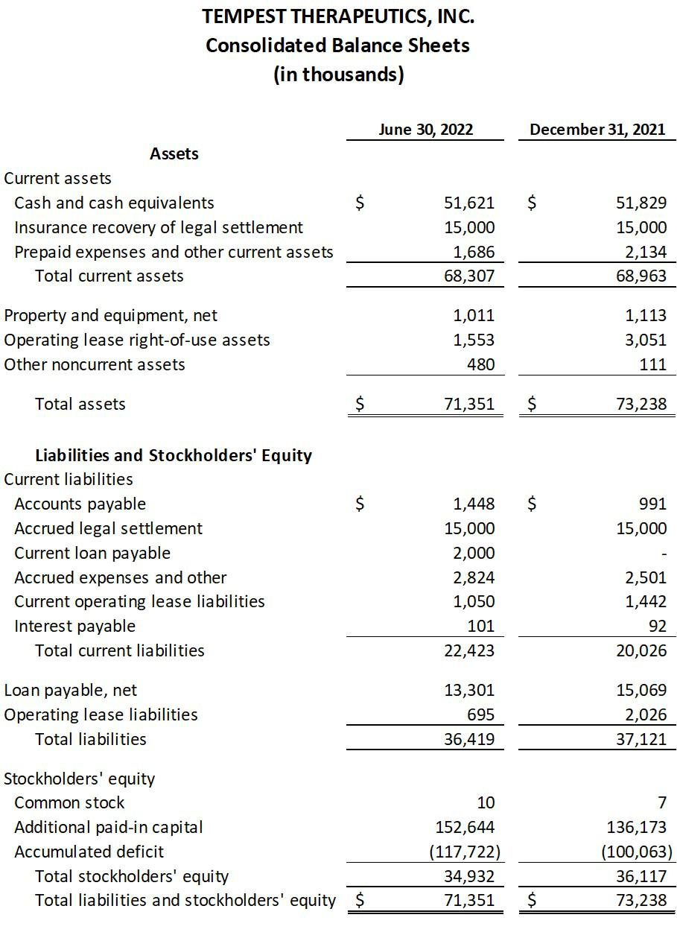

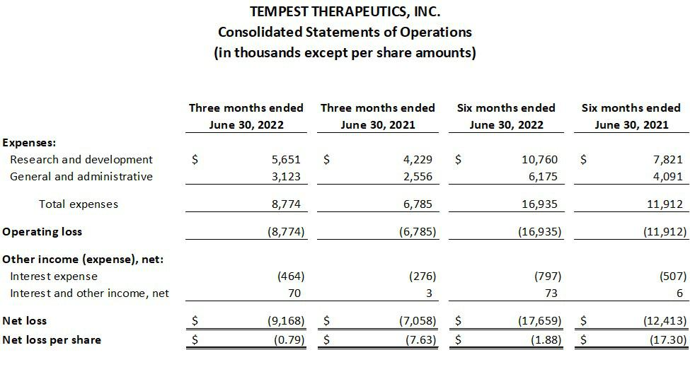

Investor Contacts:
Sylvia Wheeler
Wheelhouse Life Science Advisors

swheeler@wheelhouselsa.com

Aljanae Reynolds
Wheelhouse Life Science Advisors

areynolds@wheelhouselsa.com

